Smart Refrigerator

Business Proposal

Brody Schulke

John Walter

Daniel Leclair

Phat Tran

May 2015

# 

**Overview of Product**The Smart Refrigerator will revolutionize grocery shopping and food management. Customers will immediately find joy in the practical use and benefits associated with this product.  
  
**Current Problem**The common refrigerator is a standard of living for every household. Unfortunately, shopping for groceries and keeping track of food consumes an enormous amount of time -- a luxury that no one has. To make matters worse, people frequently make the mistake of purchasing unnecessary food items or forgetting to purchase essential items. The cumbersome process of managing food burdens the life of the consumer.

**Solution**The Smart Refrigerator will become every customer’s immediate best friend. By automating the various tasks and chores that normally require manual interaction with refrigerators, customers will no longer have to worry about the dreaded process of managing food items and tracking their inventory. The Smart Refrigerator keeps track of what you have and what you need, and if you can’t take the time out of your day to get to the store, the Smart Refrigerator can place orders on your behalf. With the Smart Refrigerator, plans for cooking a meal will never be thwarted again because any or all of the ingredients are expired or missing.

**Stakeholders**One stakeholder is the customer: the targeted audience for the Smart Refrigerator are homeowners in the middle to upper-class earning brackets. The perks of owning such a product are applicable to anyone who has to deal with food they buy and refrigerate; however, renters of homes will generally not be interested in acquiring their own refrigerators, and landlords will typically not install more than a basic refrigerator for tenants.

A second stakeholder is Amazon: through Amazon Fresh, users can automatically order their needed groceries using the Smart Refrigerator. By getting involved with Amazon, the Smart Refrigerator will integrate the Amazon Fresh service into the system. This way, ordering groceries will be easier and quicker than ever before. Continuing to do business with Amazon Fresh, we will make a deal to have access to their cloud services. This would allow some back-up storage and external access to the Smart Refrigerator for users.

A third stakeholder is the web recipe service *allrecipes.com*. By connecting their services to the Smart Refrigerator, customers will have quick and easy access to thousands of recipes and common ingredient substitutes. The Smart Refrigerator will then be able to determine whether it has the necessary ingredients for a planned meal, and if not, whether it has a satisfactory substitute or needs to make an order.

Figure 1 represents the various interactions between Smart Refrigerator and the stakeholders, including many example of the services offered and actions possible.

**Figure 1: Smart Refrigerator Context Diagram**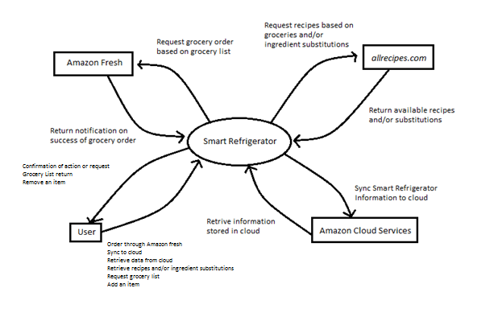

**Economic Feasibility**The Smart Refrigerator will make money initially through selling Smart Refrigerator units. The free services offered with the system increase the appeal to many users.

The cloud based inventory tracking service could also be monetized. This information can be sold to food services and chains in order to analyze markets in varying regions. As investments in the Smart Refrigerator increase, more data will be available to be sold to these companies.

**Risk Analysis and Management**

**RM-01 Low User-base**

|  |  |  |  |
| --- | --- | --- | --- |
| **Risk** | **Probability** | **Impact** | **Mitigation Strategy** |
| Low sales | High | High | Advertise product through allrecipes.com and Amazon Fresh |
| Unable to match consumer requests of product | Low | Medium | Increase production of product |

**RM-02 System Security**

|  |  |  |  |
| --- | --- | --- | --- |
| **Risk** | **Probability** | **Impact** | **Mitigation Strategy** |
| Hackers manipulate inventory database | Medium | Low | System re-analyzes refrigerator and updates inventory |
| Hackers use account to order own groceries | Medium | High | System takes permanent address, takes one week to update, notifies user of pending change |
| Hackers access payment information of users | Medium | High | Amazon handles payment security |
| Hackers retrieve customer’s information include address, phone number | Medium | High | Amazon handles customer information security |
| Hackers retrieve customer’s current inventory stock | Medium | High | Data will be stored and sent across the network using PGP encryption |
| Hackers retrieve customer’s history of purchase orders | Medium | High | Data will be stored encrypted within local disk drive |

**RM-03 System not working properly**

|  |  |  |  |
| --- | --- | --- | --- |
| **Risk** | **Probability** | **Impact** | **Mitigation Strategy** |
| Refrigerator fails to update inventory | Low | Medium | System checks for hardware issues and prompts user to intervene for custom input |
| Refrigerator returns inaccurate grocery list | Low | High | Have system update inventory before returning list, so most recent updates are accounted for |
| Refrigerator fails to access Amazon Fresh | Low | Low | System does connection checks every hour, and inform user if connection is down and the cause |
| Refrigerator fails to access allrecipes.com | Low | Medium | System does connection checks every hour, and inform user if connection is down and the cause |
| Refrigerator cannot recognize inserted item | High | Medium | Alert user that new item is unrecognizable, and allow for custom input from user |
| Refrigerator fails to recognize item that has been removed | Low | High | Alert user that removed item is unrecognizable, all for custom input from user, and notify manufacturer of bug in refrigerator software |
| Smart Device fails to sync and access Smart Refrigerator | Medium | Medium | Alert user that connection is not currently possible, and the cause. Notify user when connection is next possible |
| System unable to upload data to cloud | Medium | Medium | Amazon handles cloud services |
| System unable to save data to local database | Medium | Medium | Upload data to cloud |
| System unable to save data and upload to cloud | Low | High | Perform system check, and make updates when system resolves problem |

**RM-04 Project Runs Over Schedule**

|  |  |  |  |
| --- | --- | --- | --- |
| **Risk** | **Probability** | **Impact** | **Mitigation Strategy** |
| Developers encounter problems implementing necessary features | Medium | Medium | Preform feasibility studies to ensure all technical features are implementable. |
| Manufactured parts do not meet specified tolerances. | Medium | High | Inspect one sample part from each factory machined part per lot |

**Project Plan**

The Smart Refrigerator is planned to be completed by November of 2016. To accomplish this, there will be a team of 20 developers working on the product. There will need to be access to specific hardware components and external companies

to piece the refrigerator together. During this time, the development team will be negotiating with Amazon for use of their web services and with allrecipes.com for use of their recipe database and collaboration. After six months, in November 2015, an alpha prototype is planned to be completed for a demonstration of the product’s main features. The prototype’s features will include autodetecting it’s inventory, recognition of item/remove, and the ability to update an item’s properties after insertion/removal. After another six months, in May 2015, our beta prototype will be release with all of the product’s essential features. This beta will test our security requirements such as protection of data within the refrigerator, data sent to our servers, and data sent to connected devices. A financial analyst will be recruited to manage the spending of our funds in order to not exceed the budget limit. By consistently using version control and saving back-ups of our software, the risk of a failed project or loss of progress will be mitigated.

**Software Requirements**

**1.1 Functional Requirements**The functional requirements have been placed into four separate categories. The categories include “Inventory Tracking Requirements”, “User Notification Requirements”, “Information Generating Requirements”, and “Other Services Requirements”.

**1.1.1 Inventory Tracking Requirements**

|  |  |
| --- | --- |
| **Requirement ID** | **Requirement** |
| FR-IT-01 | Should use the tracking system to keep inventory of the user’s refrigerator |
| FR-IT-01.01 | Should be able to recognize when an item is inserted into the refrigerator |
| FR-IT-01.01.01 | Should be able to recognize if the item is a new item or replacing an existing item |
| FR-IT-01.01.02 | Should be able to recognize changes in mass or volume of existing items |
| FR-IT-01.02 | Should be able to recognize when an item is removed from the refrigerator, including changes in mass or volume of the existing item. |
| FR-IT-01.03 | Must be connected to its database to store the inventory information |
| FR-IT-01.04 | Should store information about length and expiration related to individual items in inventory |
| FR-IT-01.05 | Should allow user to customize time-span of individual items for users to choose when particular items need to be used by |

**1.1.2 User Notification Requirements**

|  |  |
| --- | --- |
| **Requirement ID** | **Requirement** |
| FR-UN-01 | Must notify user when certain items are running low |
| FR-UN-01.01 | User must be able to define “low” volume percentage or remaining quantity |
| FR-UN-02 | Must notify user when certain items are about to expire |
| FR-UN-02.01 | User must be able to define number of days before expiration notification |

**1.1.3 Information Generating Requirements**

|  |  |
| --- | --- |
| **Requirement ID** | **Requirement** |
| FR-IG-01 | Must be able to generate shopping lists based on user’s buying habits and inventory stock. |
| FR-IG-01.01 | Must be able to edit a shopping list after it has been created. |
| FR-IG-02 | Must be able to generate a list of recipes based on current inventory |
| FR-IG-02.01 | Should be able to find alternatives to missing ingredients for recipes. Alternative should also be based on current inventory. |

**1.1.4 Other Services Requirements**

|  |  |
| --- | --- |
| **Requirement ID** | **Requirement** |
| FR-OS-01 | Must be able to connect with other smart devices specifically supported computers and smartphones |
| FR-OS-01.01 | Supported devices: PC: Windows; Mac  Handheld: Android; iOS |
| FR-OS-02 | Must be able to self-order groceries through Amazon Fresh using generated shopping lists |

**1.2 Non-Functional Requirements**

The following non-functional requirements have been grouped into one general category. There are six “ilities” contained within this category: security, reliability, maintainability, interoperability, usability, and portability.

**1.2.1 General Non-Functional Requirements**

|  |  |
| --- | --- |
| **Requirement ID** | **Requirement** |
| NFR-GN-01 | Inventory information must be secure from hackers (security) |
| NFR-GN-02 | The refrigerator must have an up-time of 100%(reliability) |
| NFR-GN-03 | The refrigerator’s embedded software must be easily updated and extended (maintainability) |
| NFR-GN-04 | System must be connected to external recipe database and food delivery services (interoperability) |
| NFR-GN-05 | The user-configurable functions of the refrigerator must be intuitive to the user (usability) |
| NFR-GN-06 | The system must be compatible with Windows, Mac, Linux, iOS, Android, and Windows Phone (portability) |

**Use Case Diagram**

**Figure UC-1: Smart Refrigerator Use Case Diagram**

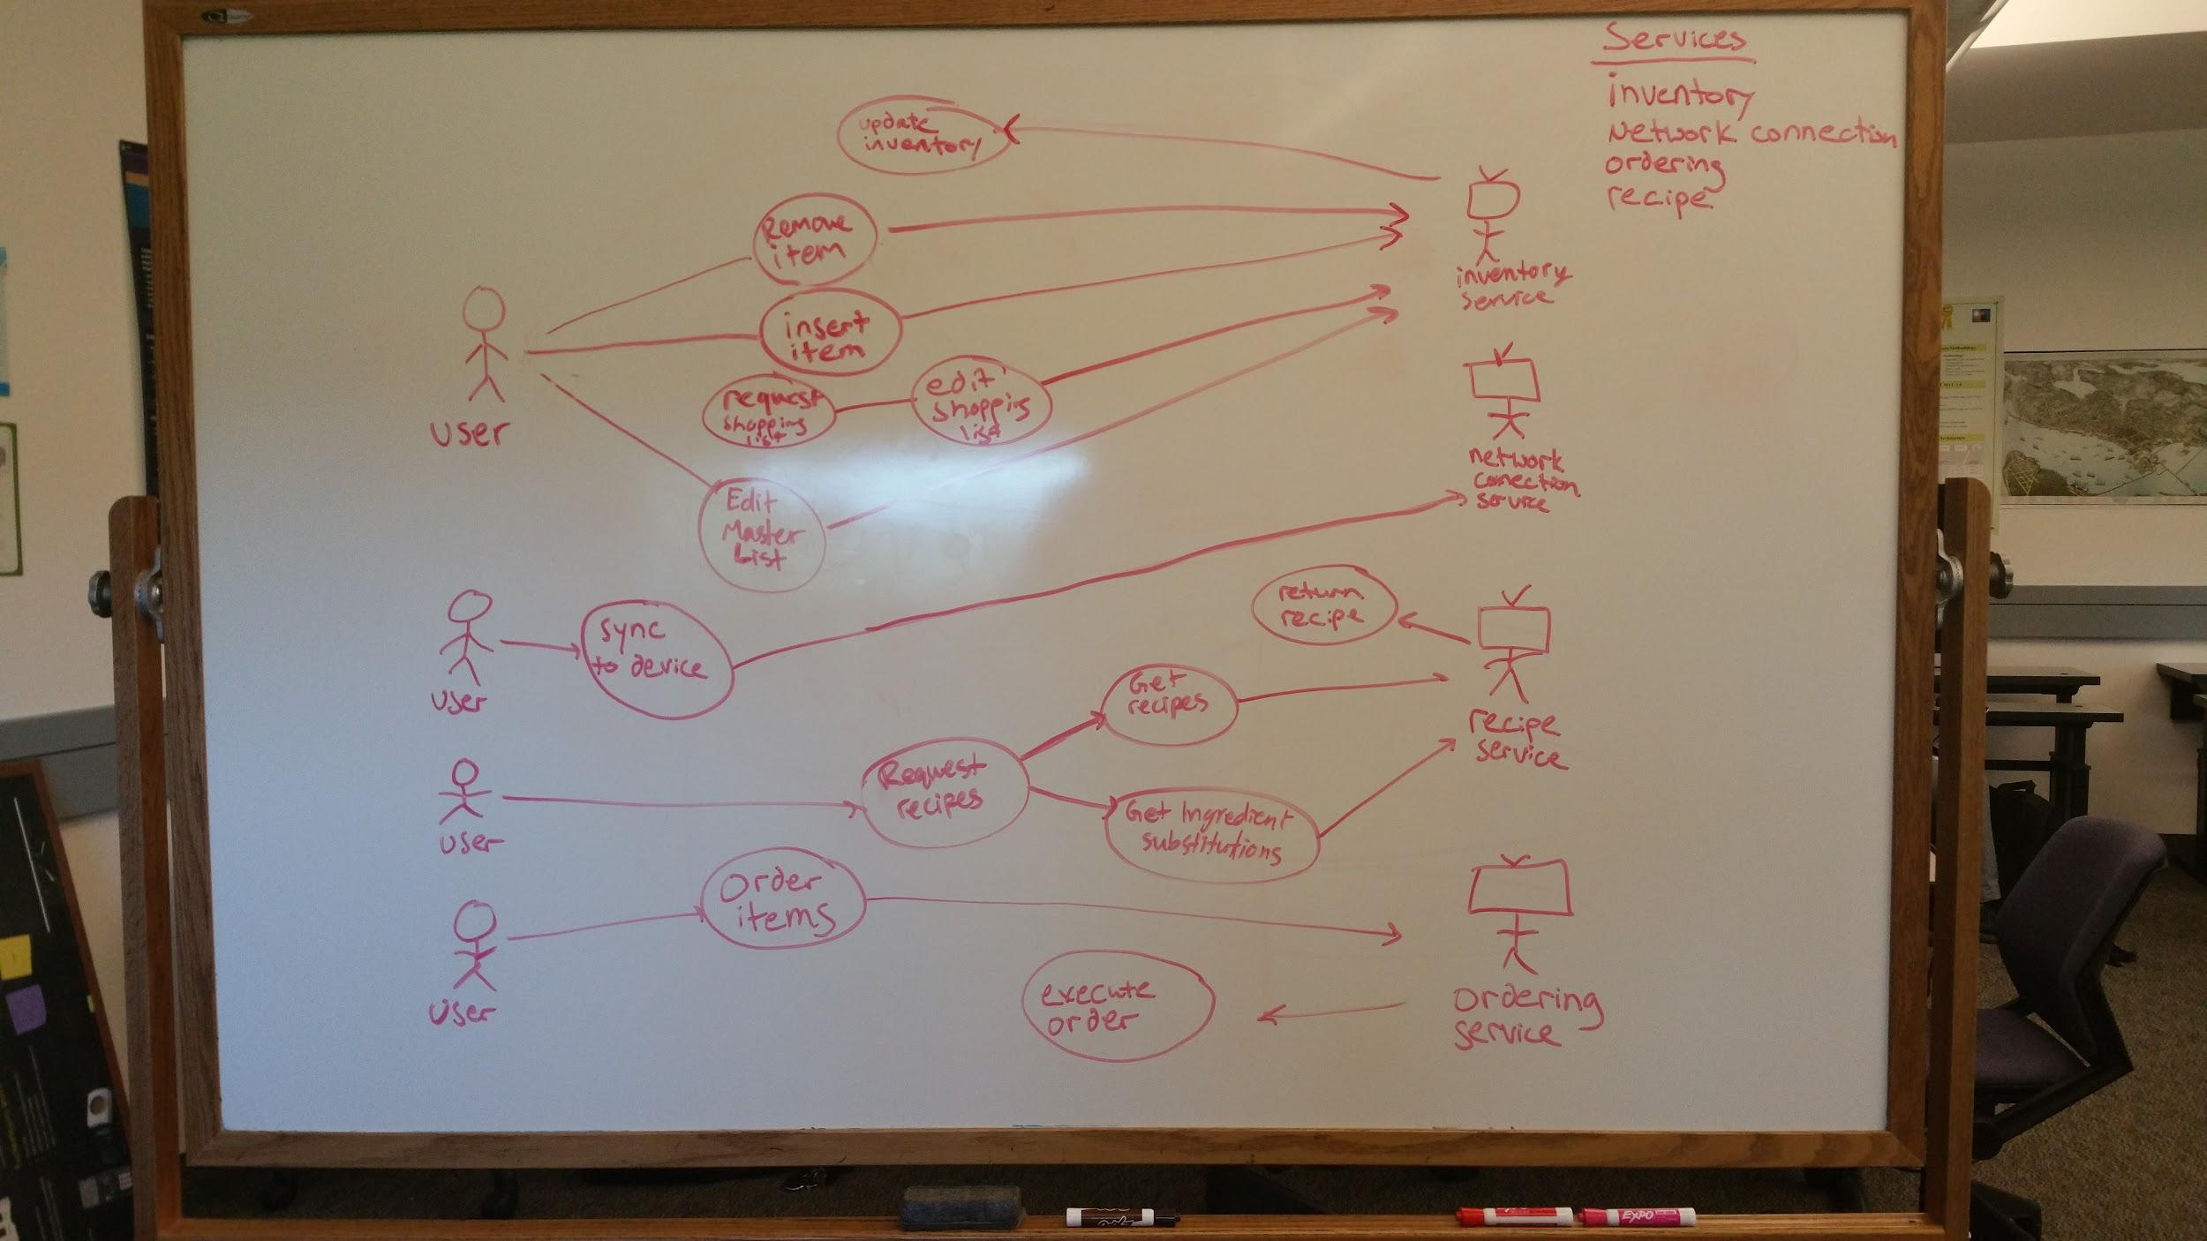

Figure UC-1 represents a use case diagram for the Smart Refrigerator. The diagram represents the interaction between a user and the Smart Refrigerator’s services. Each bubble is an activity that the Smart Refrigerator can perform and the respective service the activity would call.

**Use Cases and their Associated Diagrams**

|  |
| --- |
| **Name:** Create Shopping List    **Identifier:** FR-IG-01    **Description:**  Generates a shopping list based on current inventory stock.    **Preconditions:**  An inventory list has been created.    **Postconditions:**  User receives a shopping list of low inventory items.  **Basic Course of Action:**  1. Use case begins when user request to see shopping list.  2. User selects “generate shopping list” option.  3. System retrieves inventory list. [Alt course A]  4. System generates shopping list based on inventory  5. System displays shopping list to user.  6. User may edit shopping list via UC-IG-01.1  7.. User case ends.    **Alternate Course A:**  3A. System determines inventory list is up-to-stock.  4A. Notifies user that inventory is currently in stock.  5A. Use case ends. |

**Activity Diagram: Create Shopping List**

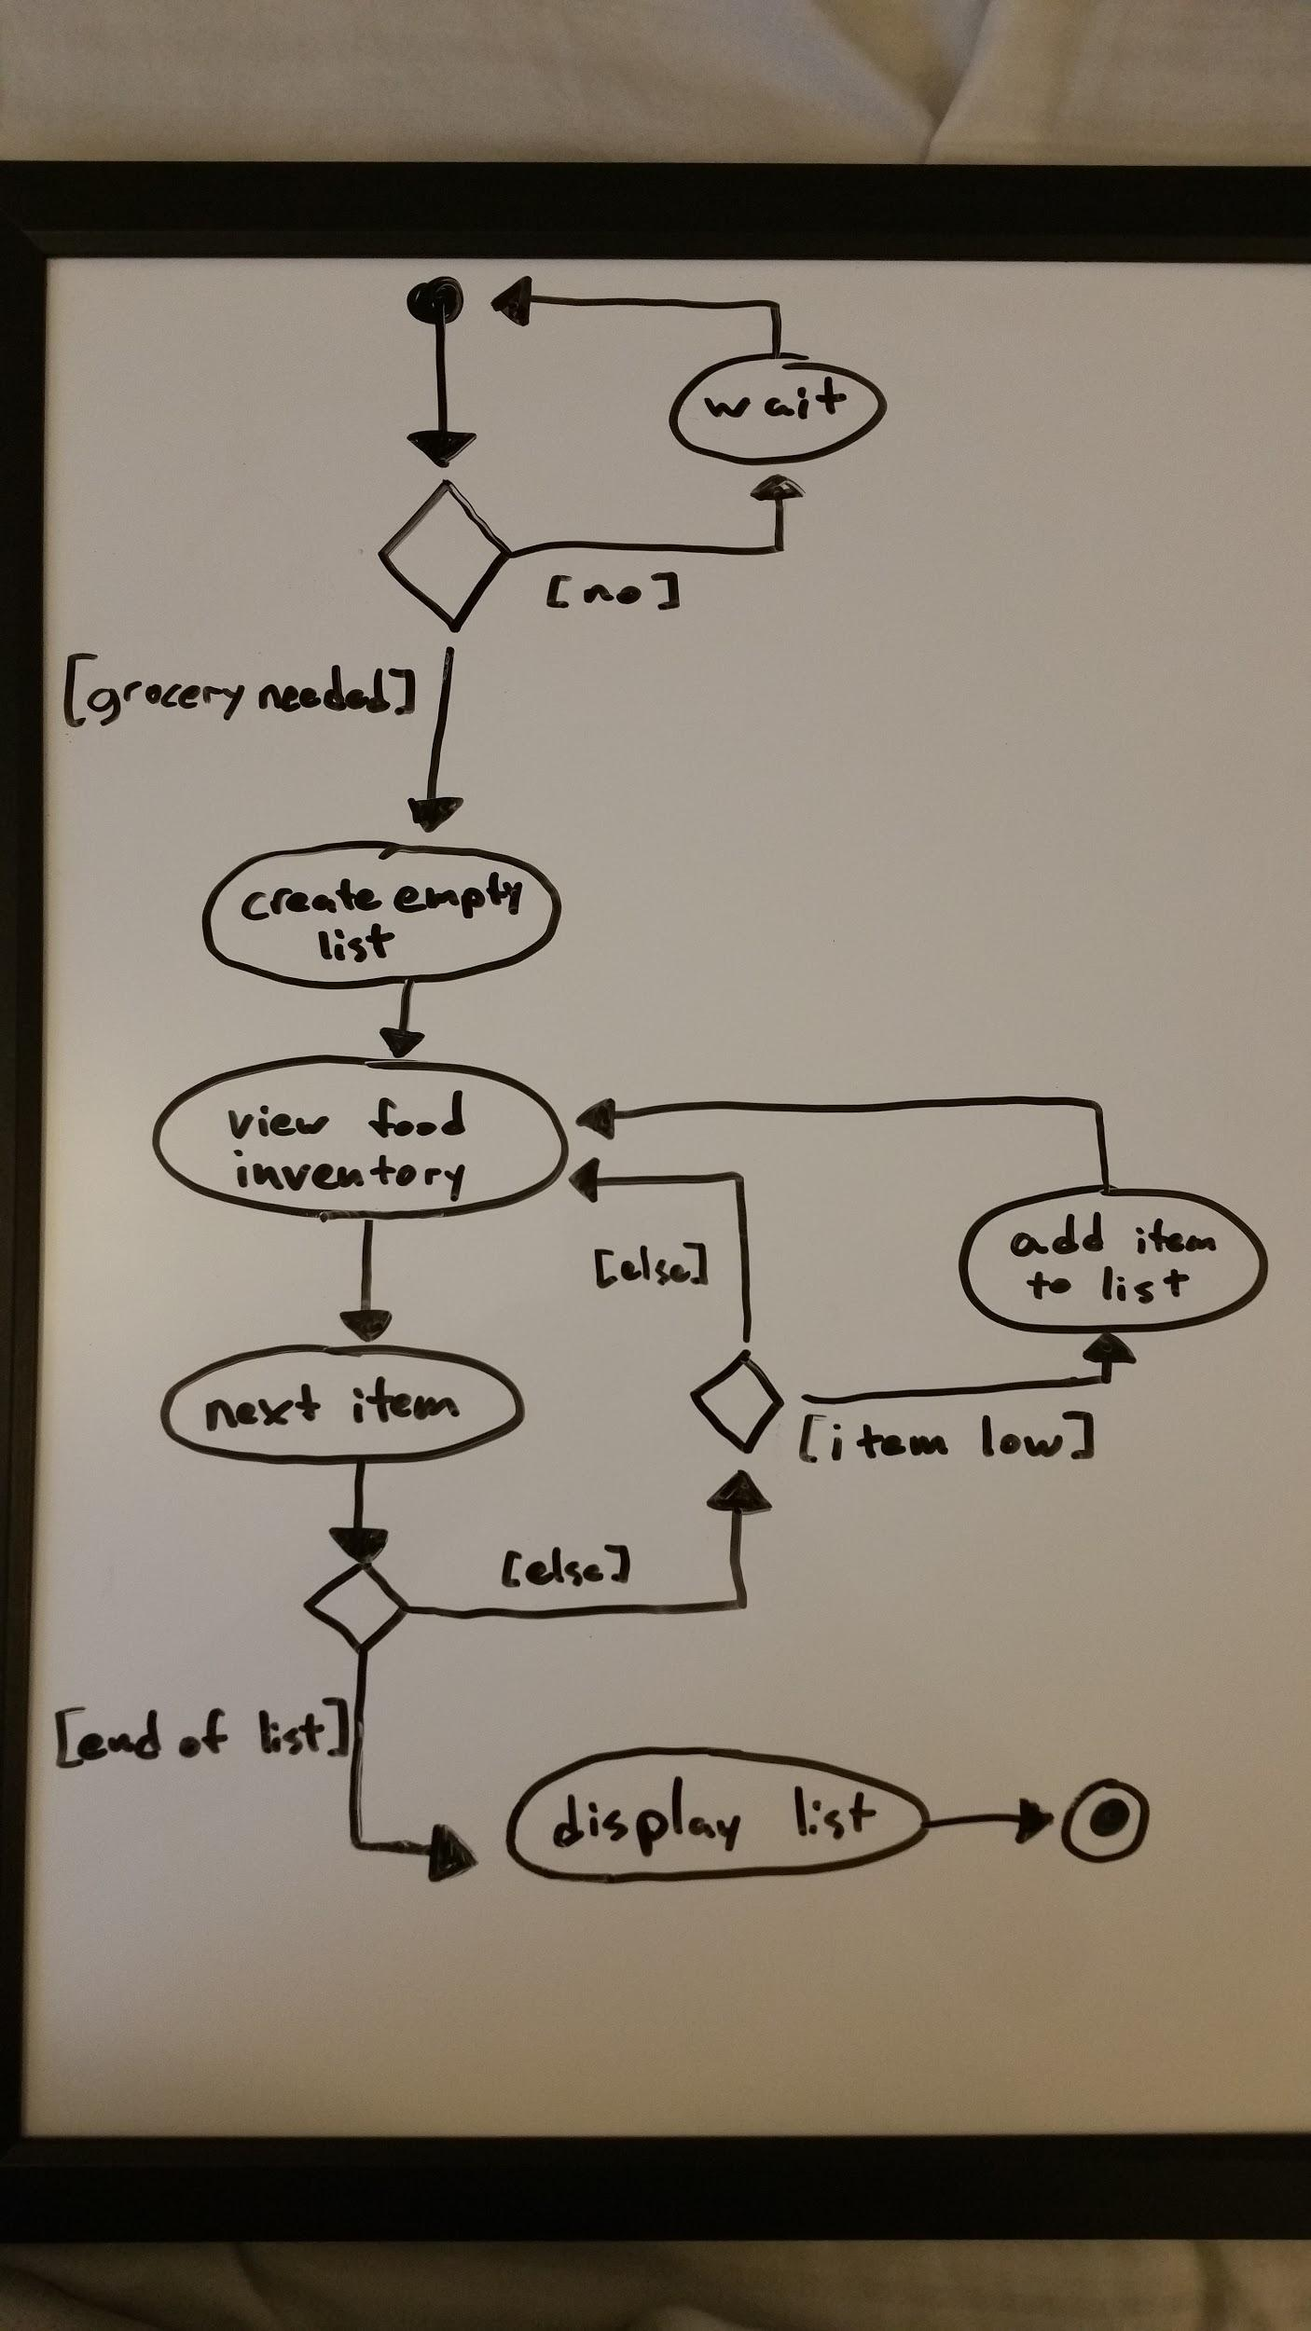

**Robustness Diagram: Create Shopping List**

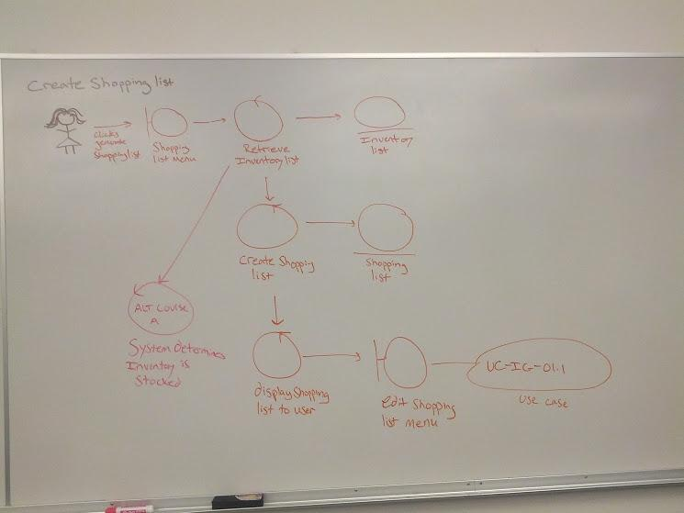

**Sequence Diagram: Create Shopping List**

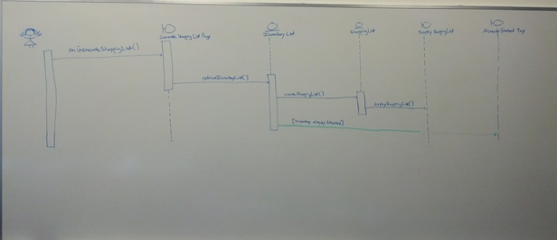

**Data Flow Diagram: Create shopping list**

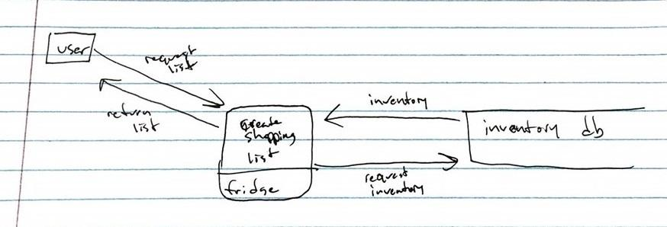

|  |
| --- |
| **Name:** Edit shopping list    **Identifier:** FR-IG-01.1    **Description:**  User customizes auto-generated shopping list    **Preconditions:**  A shopping list has been created.    **Postconditions:**  Shopping list has been edited to user’s liking.  **Basic Course of Action:**   1. User requests an auto-generated shopping list via UC-IG-01. 2. User chooses to edit the shopping list. 3. System displays a page with editable sections for customizing the shopping list. 4. User inputs desired edits. [Alt course B] 5. System shows real-time “updates”. 6. User presses save. [Alt course A] 7. System saves updated list and gives it to user. 8. User has customized shopping list. 9. Use case ends.     **Alternate Course A:** User presses cancel   1. User presses cancel. 2. System confirms cancel with notification. 3. System does not save customized list. 4. System displays list before use case began. 5. Use case ends.     **Alternate Course B:** User inputs unintentional edits   1. User accidentally puts in wrong edits. 2. User saves list. 3. User confirms save. 4. System saves list, and gives it to the user. 5. User has an unknowingly incorrect list. 6. User uses list to order groceries, ordering too much or too little. 7. Use case ends. |

**Activity Diagram: Edit Shopping List**

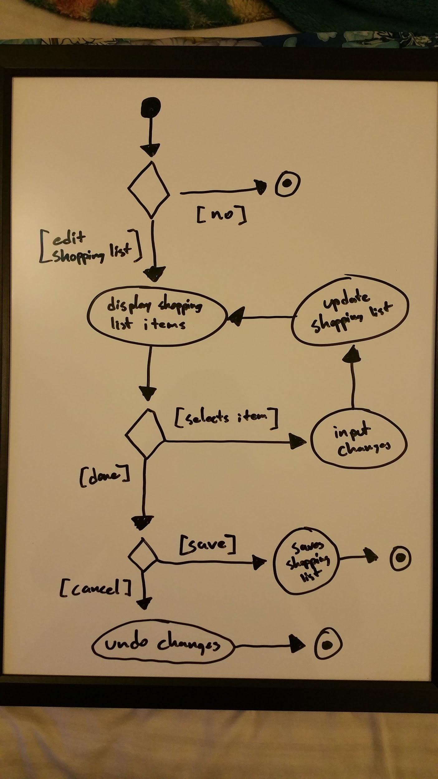

**Robustness Diagram: Edit Shopping List**

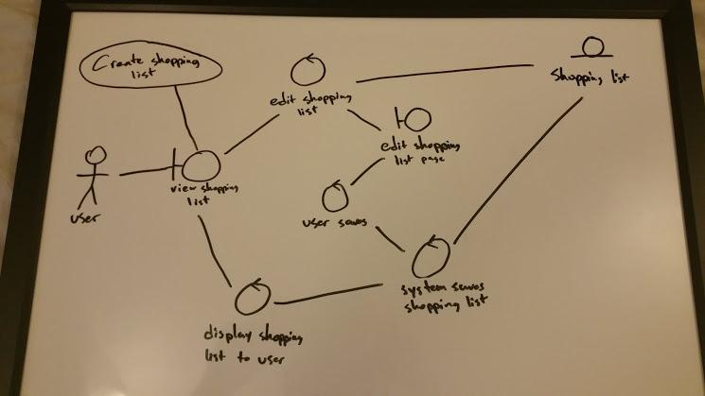

**Sequence Diagram: Edit Shopping List**

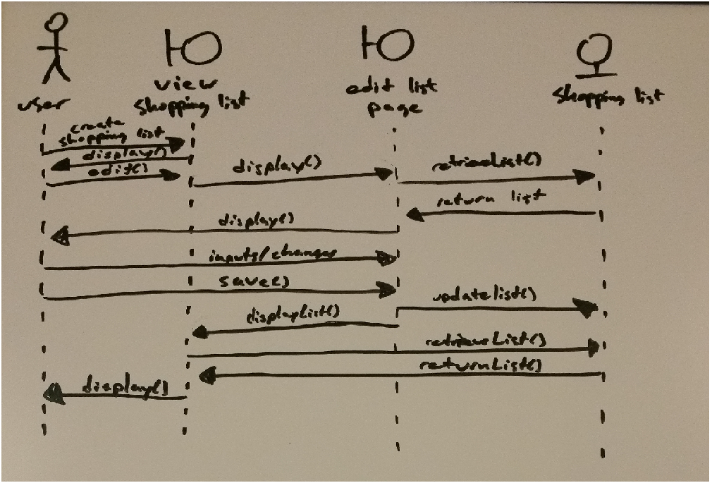

**Data Flow Diagram: Edit shopping list**

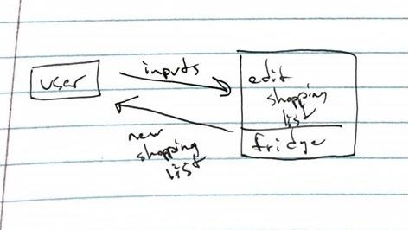

|  |
| --- |
| **Name:** Insert item  **Identifier:** FR-IT-01.01  **Description:** The user inserts an item into the refrigerator  **Preconditions:** There is sufficient space in the refrigerator to accommodate the inserted item.  **Postconditions:** The item has been checked into the system inventory and updated if necessary.  **Basic Course of Action:**   1. The user inserts a item into the refrigerator. 2. The system scans the item. 3. The system recognizes the item that it scanned, and it can discern the item’s volume and expiration data. 4. The system determines whether the scanned item is being reinserted or inserted for the first time.    1. If the item is being reinserted, the system determines if and how much the item’s volume has changed and logs the change in the inventory.    2. If the item is new to the current inventory, the system checks the item into the inventory and records the items volume and expiration information.   **Alternate Course A:** The system does not recognize the scanned item, or it cannot discern the  item’s volume or expiration information.   1. The system logs failure to identify item anomaly. 2. The system sends an alert to the user interface, prompting the user to take an action. 3. The user is given the choice whether to rescan the item, enter the item’s data manually, or ignore the problem. **The action taken by the user is subsequently continued in Use Case ID: TBT.** |

**Activity Diagram: Insert Item**

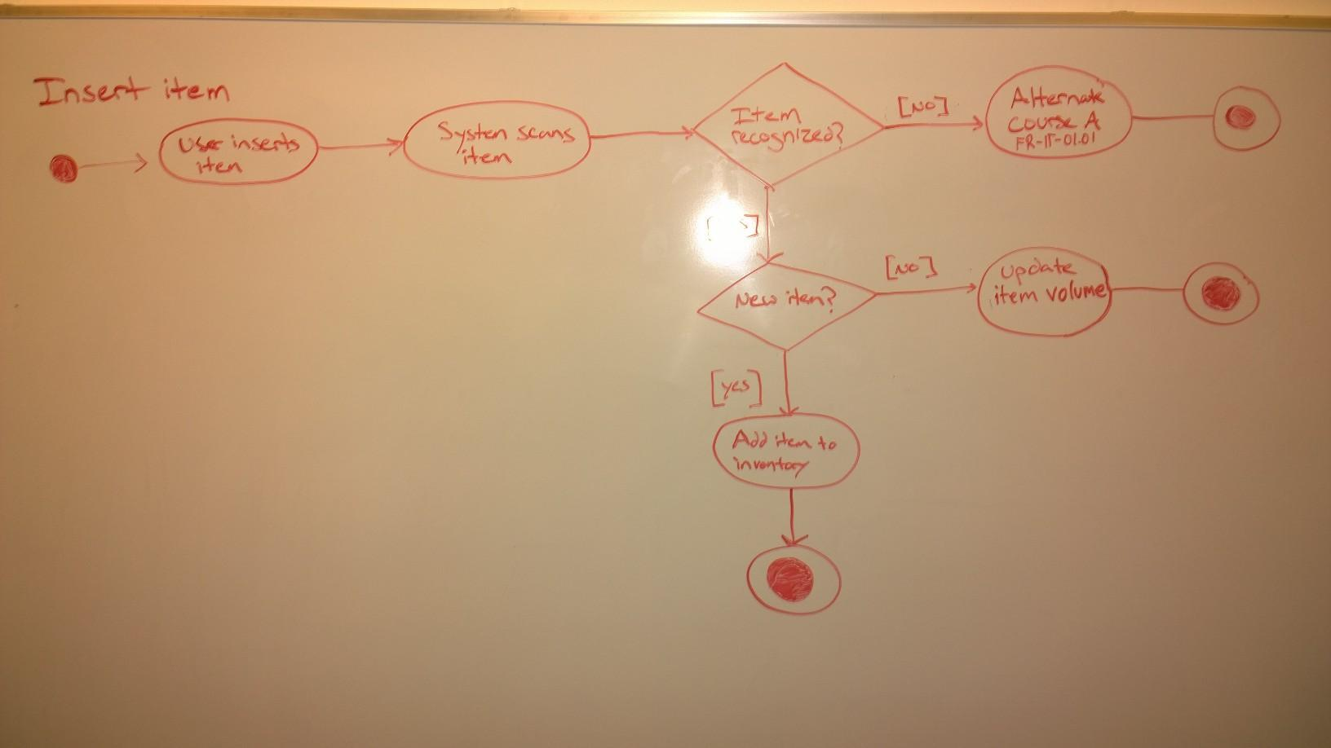

**Robustness Diagram: Insert Item**

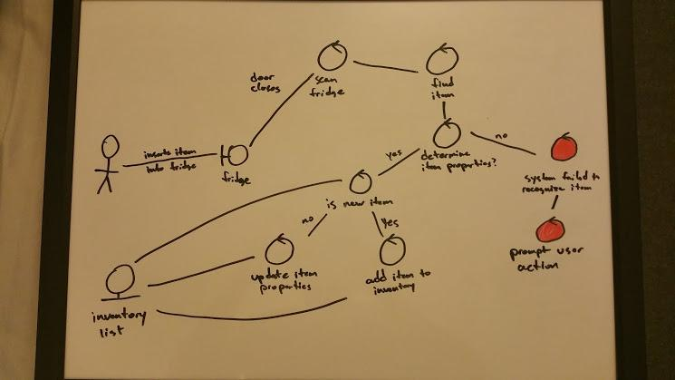

**Sequence Diagram: Insert Item**

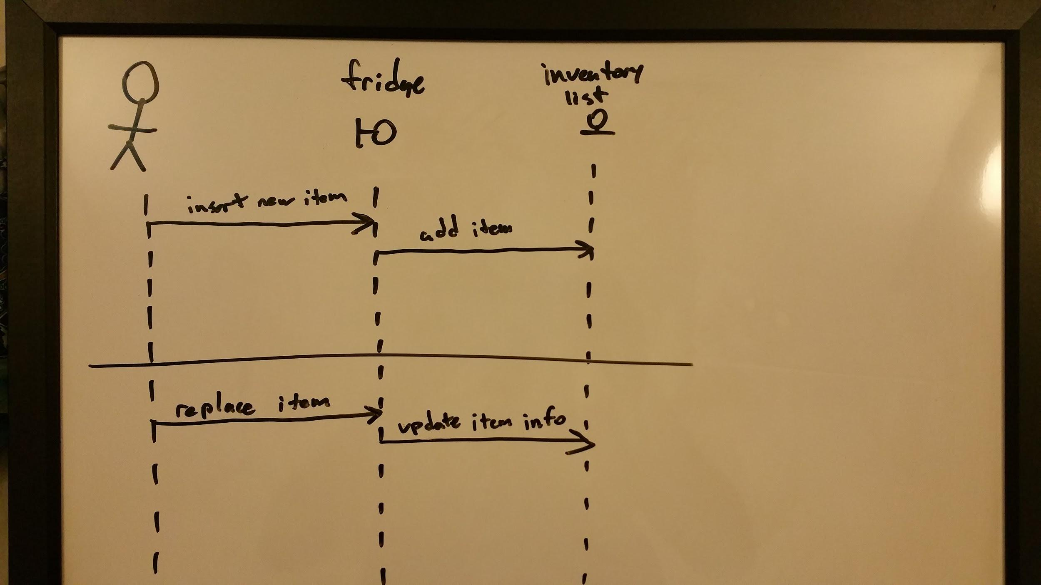

**Data Flow Diagram: Insert/Remove Item**

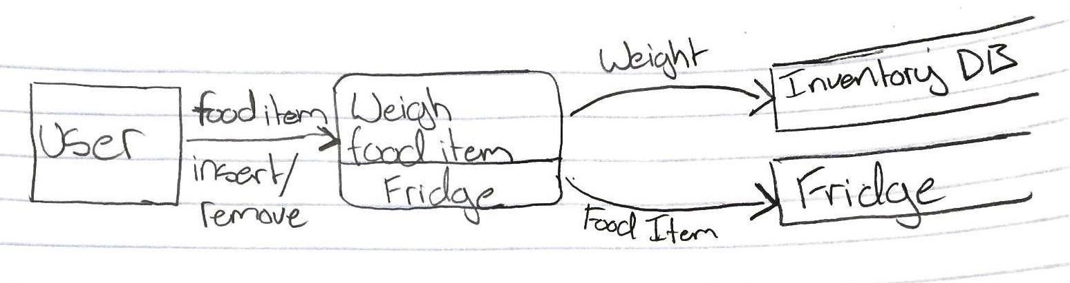

|  |
| --- |
| **Name:** Remove item  **Identifier:** FR-IT-01.02  **Description:** The user removes an item from the refrigerator  **Preconditions:** There is at least one item currently in the refrigerator  **Postconditions:** The item has been checked out of the system inventory or updated if reinserted.  **Basic Course of Action:**   1. The user removes an item from the refrigerator 2. The fridge senses that an item has been removed from the shelf, and calculates which item was removed. 3. The fridge starts a removed item timer that elapses at a time determined by the item being removed. 4. If the user reinserts the item before the timer elapses, the fridge updates the item’s quantity in the inventory. 5. If the timer elapses before the user reinserts the item, the item is removed from the inventory    1. If the user reinserts the item after the timer elapses, the fridge notifies the user that the item has exceeded safe unrefrigerated time, flags the item as potentially dangerous, and reinserts the item into the inventory.   **Alternate Course A:** The system cannot calculate which item was removed   1. The system logs failure to identify item anomaly. 2. The system sends an alert to the user interface, prompting the user to take an action. 3. The user is given the choice whether to enter the item’s data manually, or ignore the problem. **The action taken by the user is subsequently continued in Use Case ID: TBT.** |

**Activity Diagram: Remove Item**

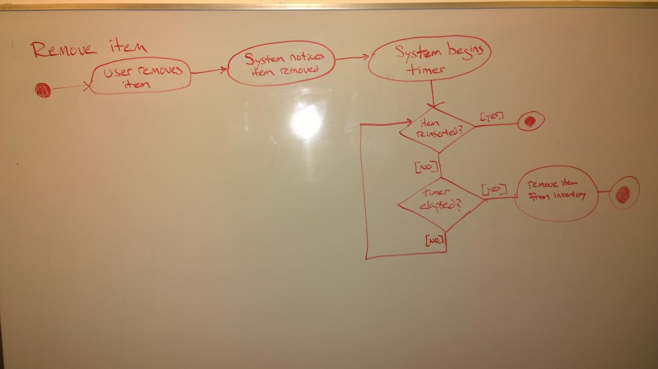

**Robustness Diagram: Remove Item**

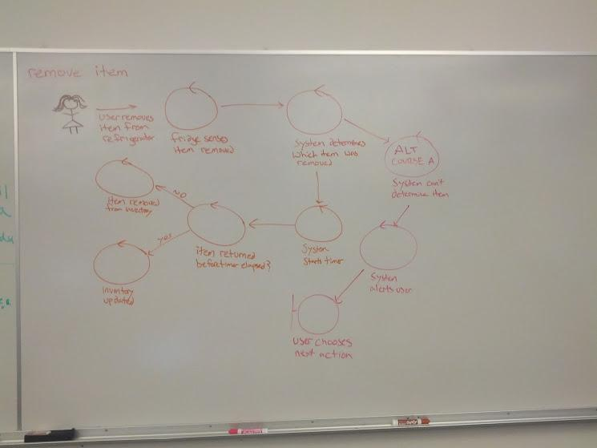

**Sequence Diagram: Remove Item**

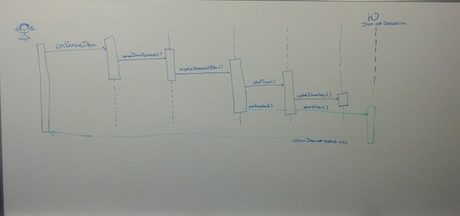

**Data Flow Diagram: Insert/Remove Item**



|  |
| --- |
| **Name:** Request Recipes  **Identifier:** FR-IG-02  **Description:** Suggest recipes based on current inventory  **Preconditions:** User has Smart Refrigerator system with updated inventory  **Postconditions:** User has successfully received a list of recipes  **Basic Course of Action:**   1. User desires recipes based on current inventory 2. User requests a recipe list from the Smart Refrigerator 3. Smart Refrigerator access allrecipes.com and returns a list of recipes available to the user 4. User now has a list of recipes that can be made from their current inventory   **Alternate Course A:**   1. User requests a recipe list from the Smart Refrigerator 2. Smart Refrigerator is unable to access allrecipes.com 3. Smart Refrigerator notifies user of issue 4. User does not have the requested list of recipes   **Alternate Course B:**   1. User requests a recipe list from the Smart Refrigerator 2. Smart Refrigerator is unable to analyze the current inventory 3. Smart Refrigerator notifies user of issue 4. User does not have the requested list of recipes |

**Activity Diagram: Request Recipes**

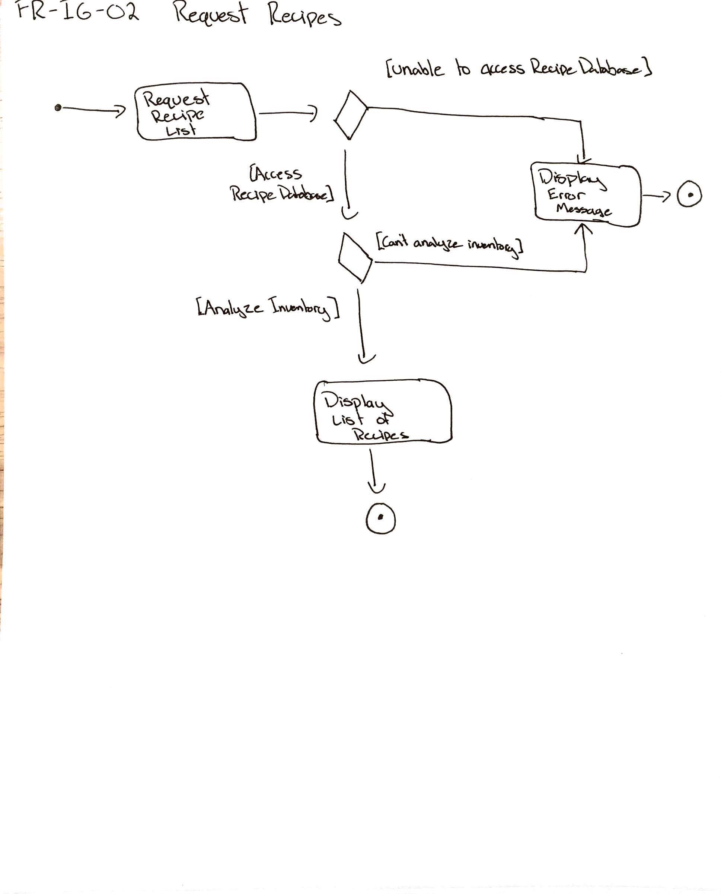

**Robustness Diagram: Request Recipes**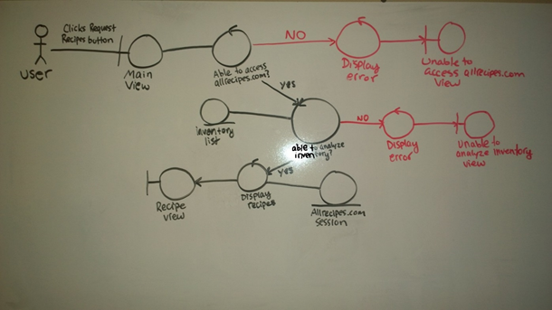

**Sequence Diagram: Request Recipes**

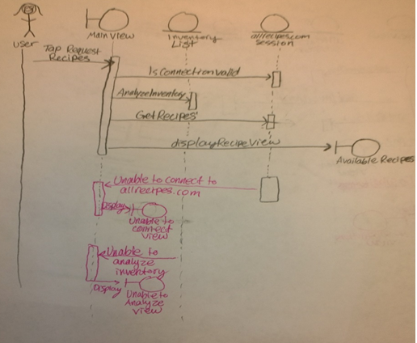

**Data Flow Diagram: Request Recipes**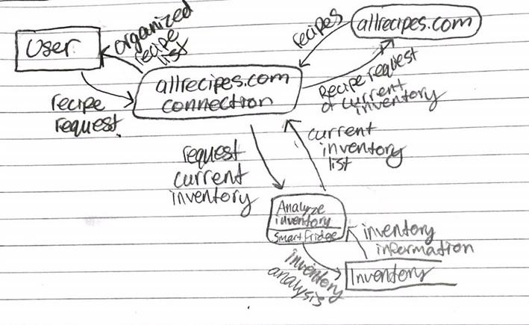

|  |
| --- |
| **Name:** Request recipe substitution  **Identifier:** FR-IG-02.01  **Description:** Suggests recipe substitutions when ingredients are not present in inventory.  **Preconditions:** The user has a Smart Refrigerator system and wants additional recipes  **Postconditions:** The user receives a list of recipes and appropriate ingredient substitutions  **Basic Course of Action**   1. User requests recipe substitutions 2. System access allrecipes.com to find possible substitutions based on current inventory 3. System displays any possible substitutions 4. User has requested substitutions   **Alternate Course A:** No substitutions for missing ingredient/ No substitutions found in inventory  2A. Allrecipes.com returns no possible substitutions based on current inventory  3A. System returns message informing user of no substitutions  4A. User has no substitutions |

**Activity Diagram: Request Recipe Substitution**

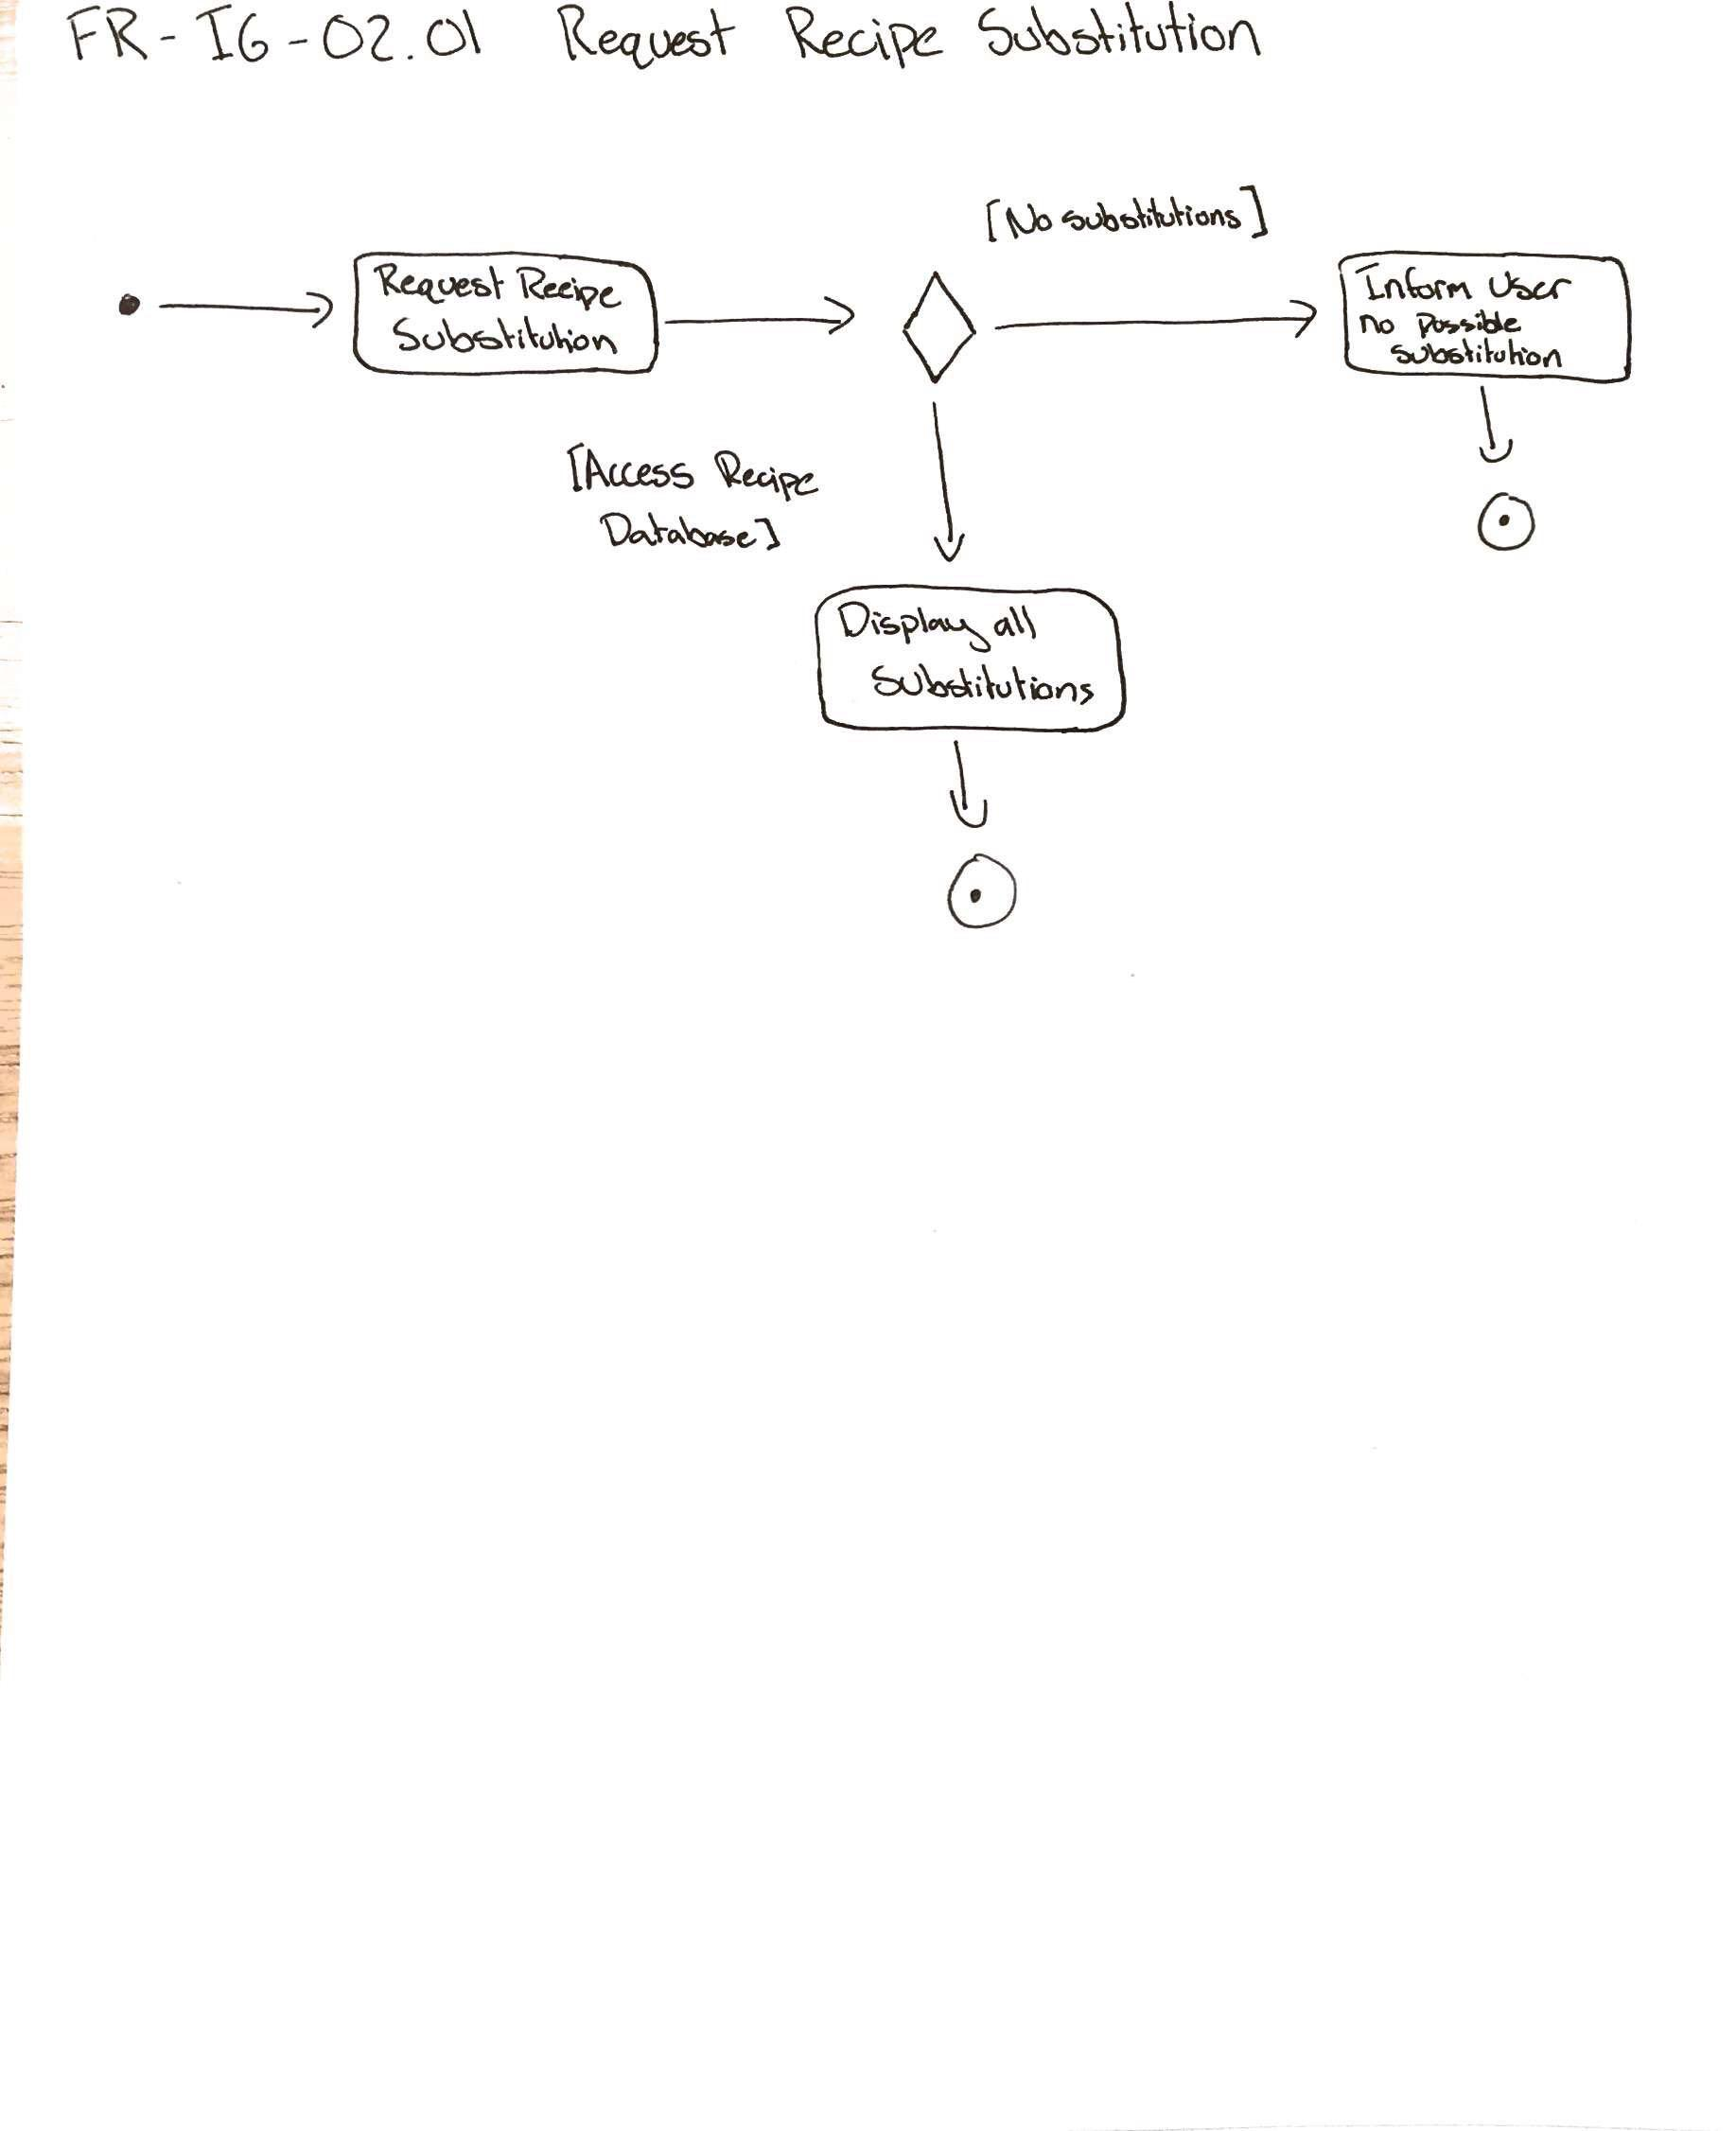

**Robustness Diagram: Request Recipe Substitutions**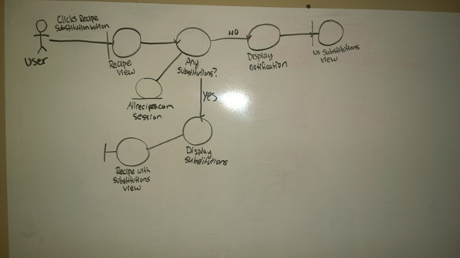

**Sequence Diagram: Request Recipe Substitutions**

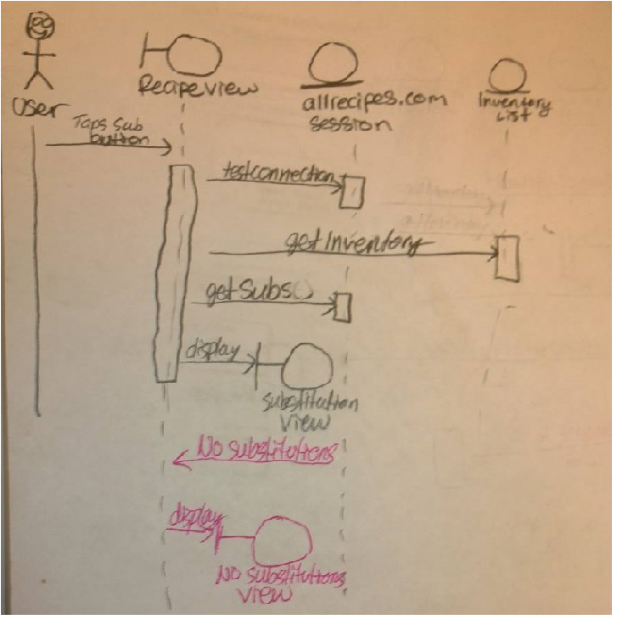

**Data Flow Diagram: Request Recipe Substitution**

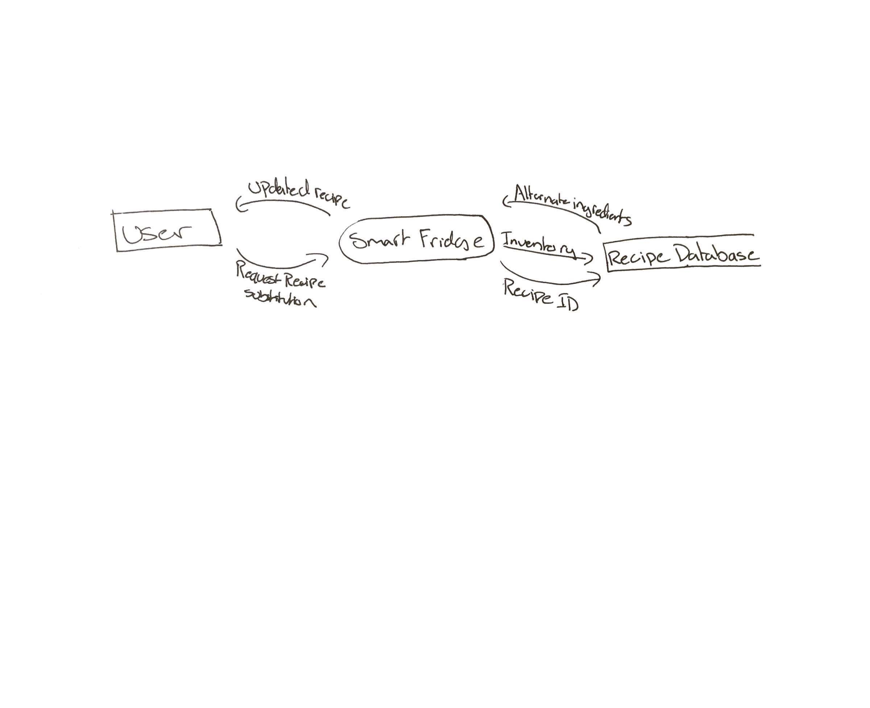

|  |
| --- |
| **Name:** Sync to Device  **Identifier:** FR-OS-01  **Description:** User syncs mobile device or computer to Smart Refrigerator  **Preconditions:** User has working device with internet access, and Smart Refrigerator is connected to  the internet  **Postconditions:** User’s device(s) connected to the Smart Refrigerator, and are able to access all  features of the Smart Refrigerator  **Basic Course of Action:**   1. User chooses to connect device to Smart Refrigerator 2. Smart Refrigerator notifies user of device attempting to connect 3. User confirms connection request on Smart Refrigerator 4. Device now connected to Smart Refrigerator and has access to all functional features   **Alternate Course A:** Device not recognized   1. User chooses to connect device to Smart Refrigerator 2. Smart Refrigerator fails to recognize device attempting to connect   **Alternate Course B:** Connection failed   1. User chooses to connect device to Smart Refrigerator 2. Smart Refrigerator notifies user that a device is attempting to connect 3. User confirms connection request 4. Smart Refrigerator fails to connect successfully to device |

**Activity Diagram: Sync to Device**

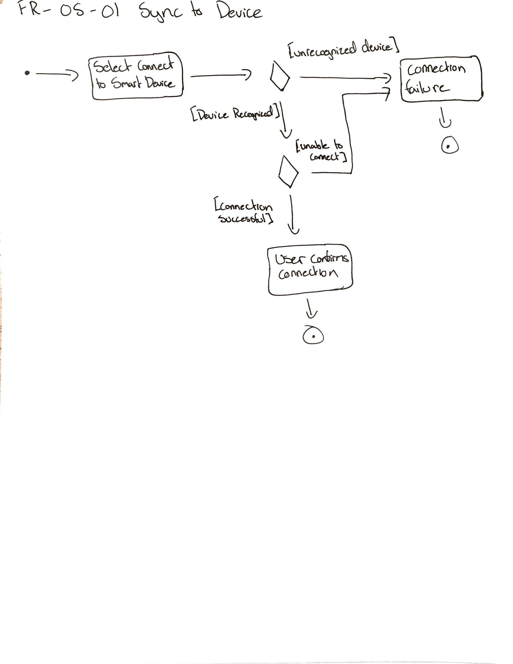

**Robustness Diagram: Sync to Device**

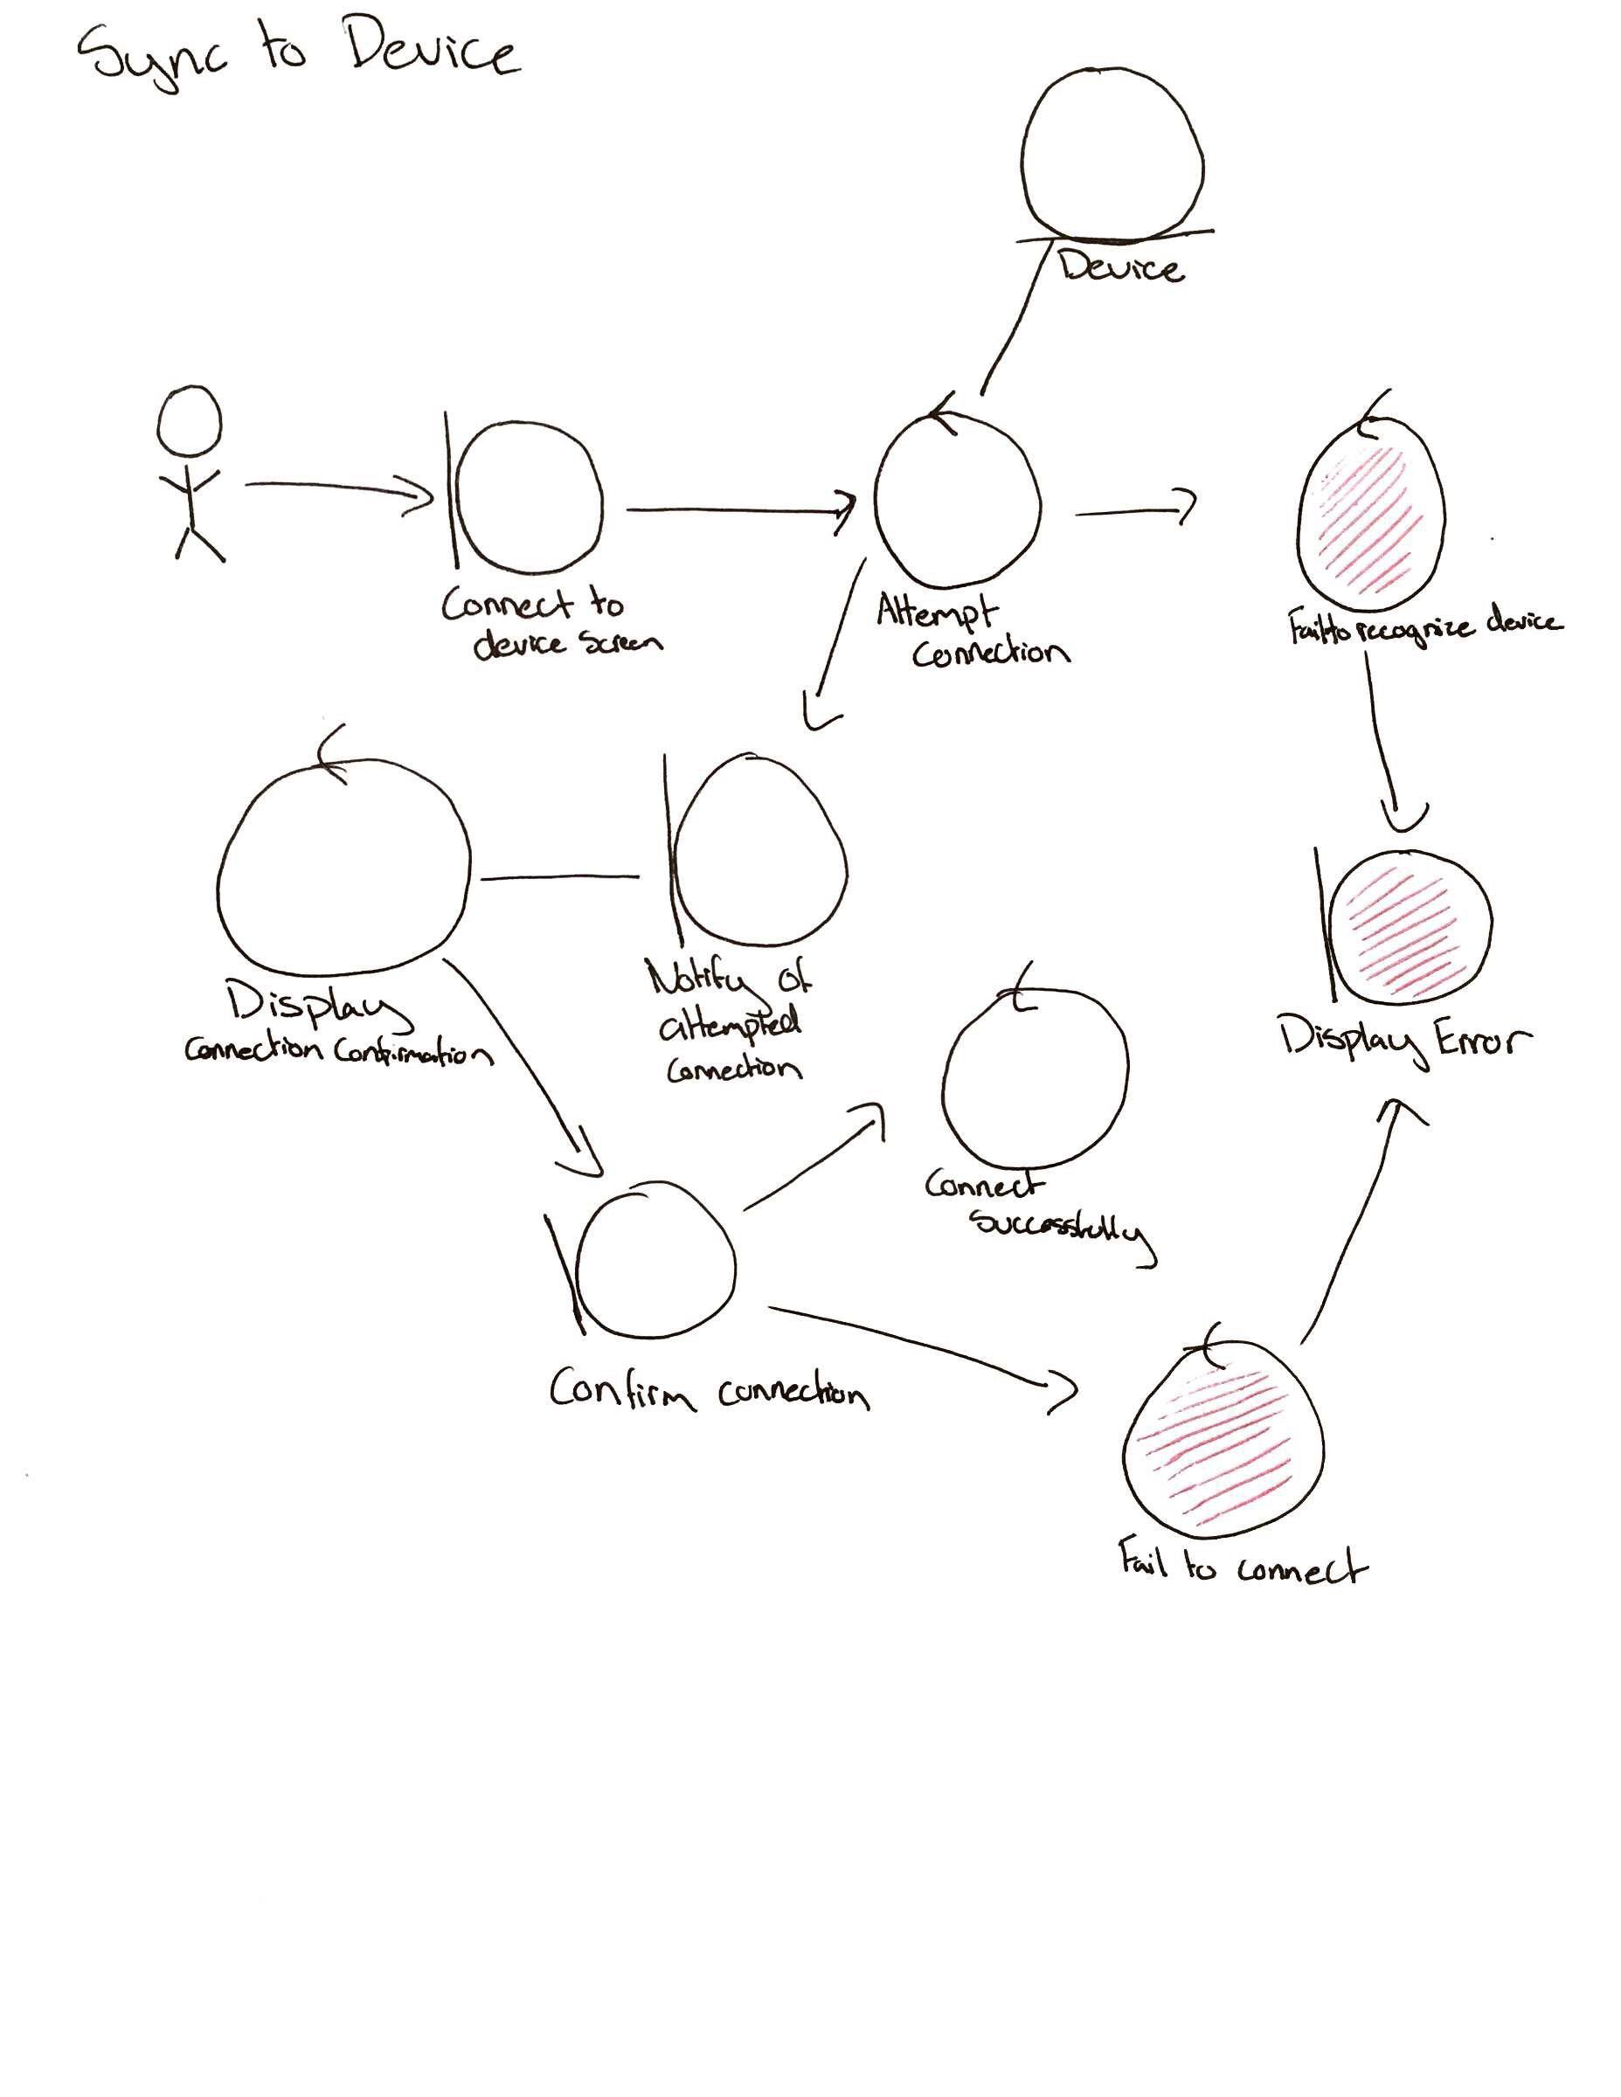

**Sequence Diagram: Sync to Device**

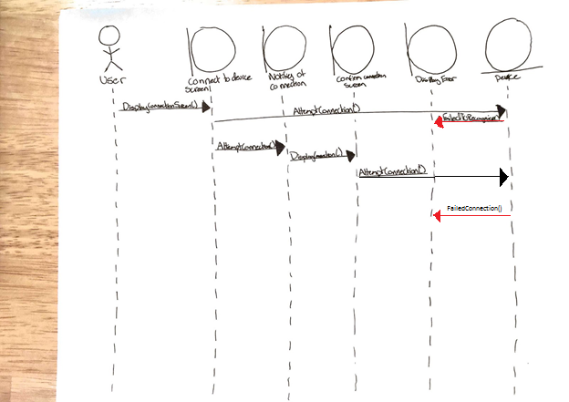

**Data Flow Diagram: Sync to Device**

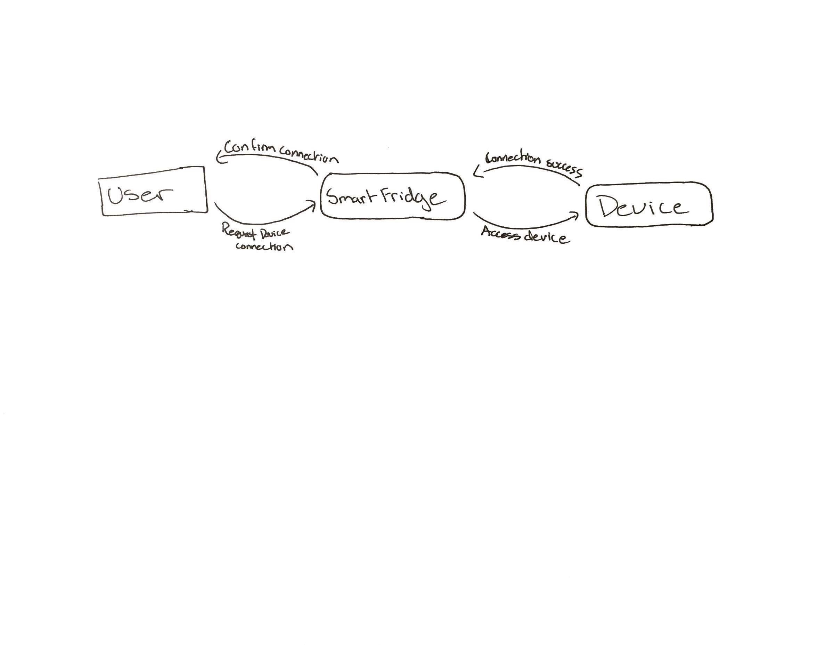

|  |
| --- |
| **Name:** Order Groceries through Amazon Fresh  **Identifier:** FR-OS-02  **Description:** User uses requested shopping list to order more groceries through Amazon Fresh  **Preconditions:** User has Smart Refrigerator system and internet access  **Preconditions:** Groceries successfully ordered through Amazon Fresh using generated shopping list  **Basic Course of Action:**   1. User requests a shopping list (see Use Case Identifier FR-IG-01 and FR-IG-01.01) 2. User chooses to order groceries 3. System brings user to page containing a cart of all shopping list items 4. User accepts the order 5. System processes order through Amazon Fresh 6. User notified of successful order   **Alternate Course A :** Unable to access Amazon Fresh   1. User chooses to order groceries 2. System unable to access Amazon Fresh 3. User notified of failed connection   **Alternate Course B:** User chooses not to order groceries   1. System returns to main screen   **Alternate Course C:** User does not accept the order   1. System returns to display cart page |

**Activity Diagram: Order Groceries through Amazon Fresh**

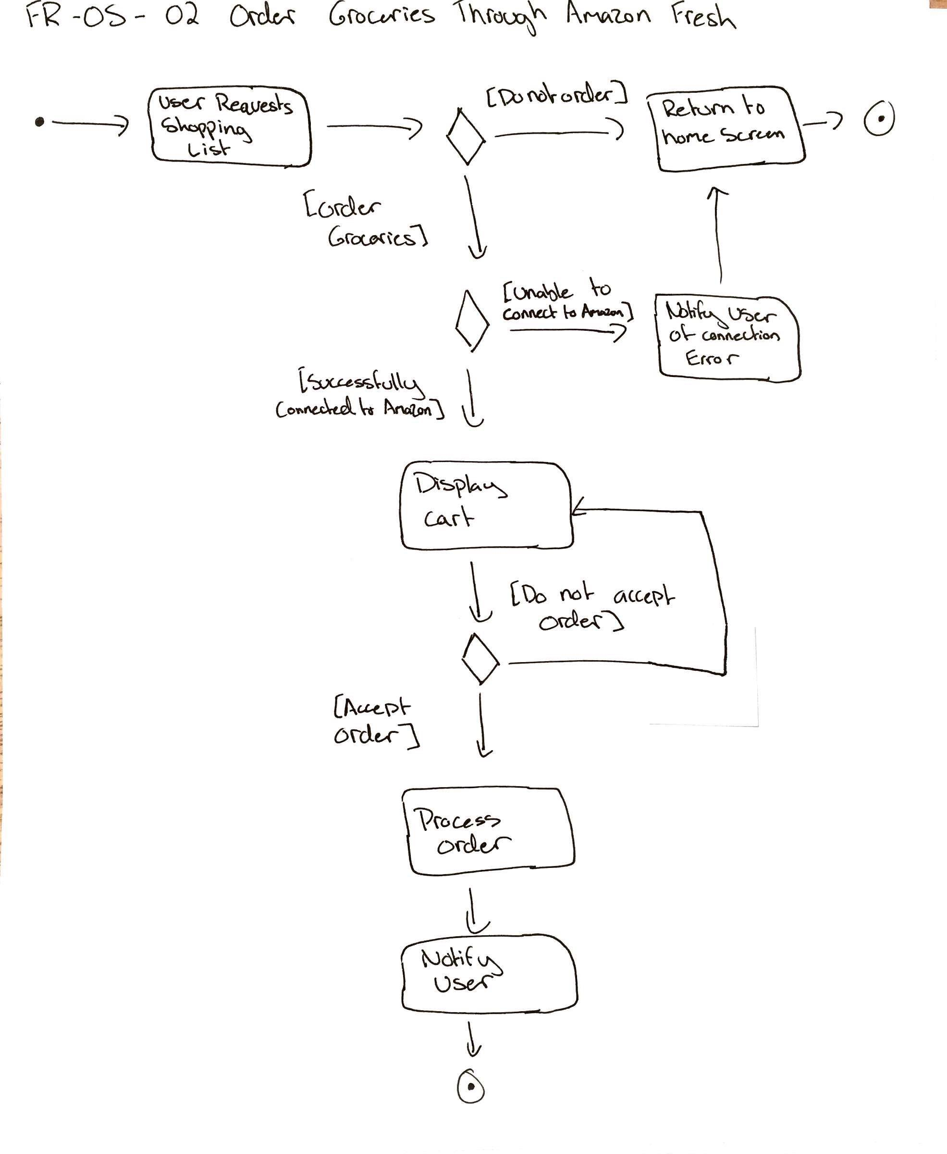

**Robustness Diagram: Order Groceries through Amazon Fresh**

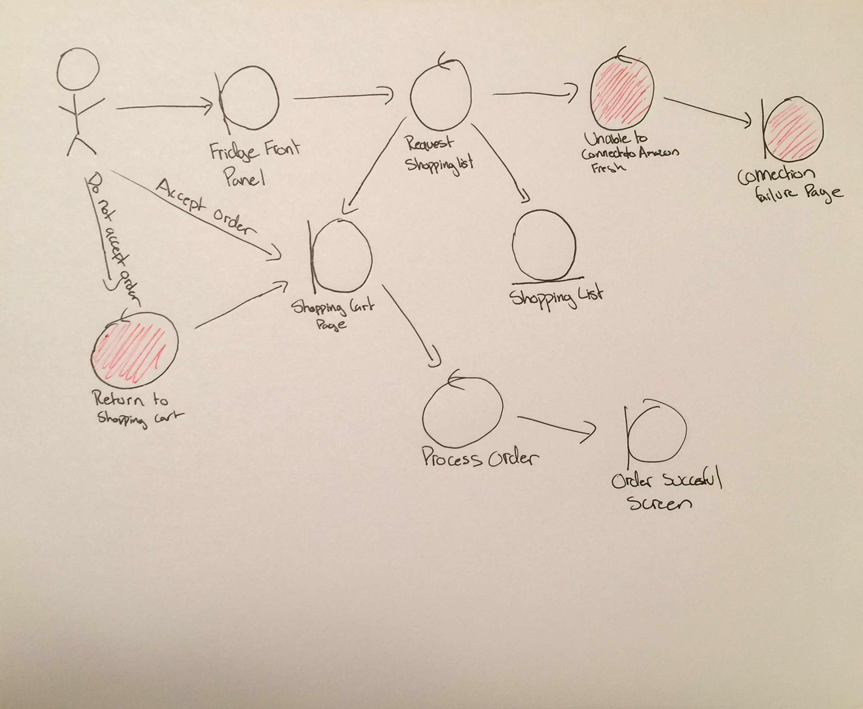

**Sequence Diagram: Order Groceries through Amazon Fresh**

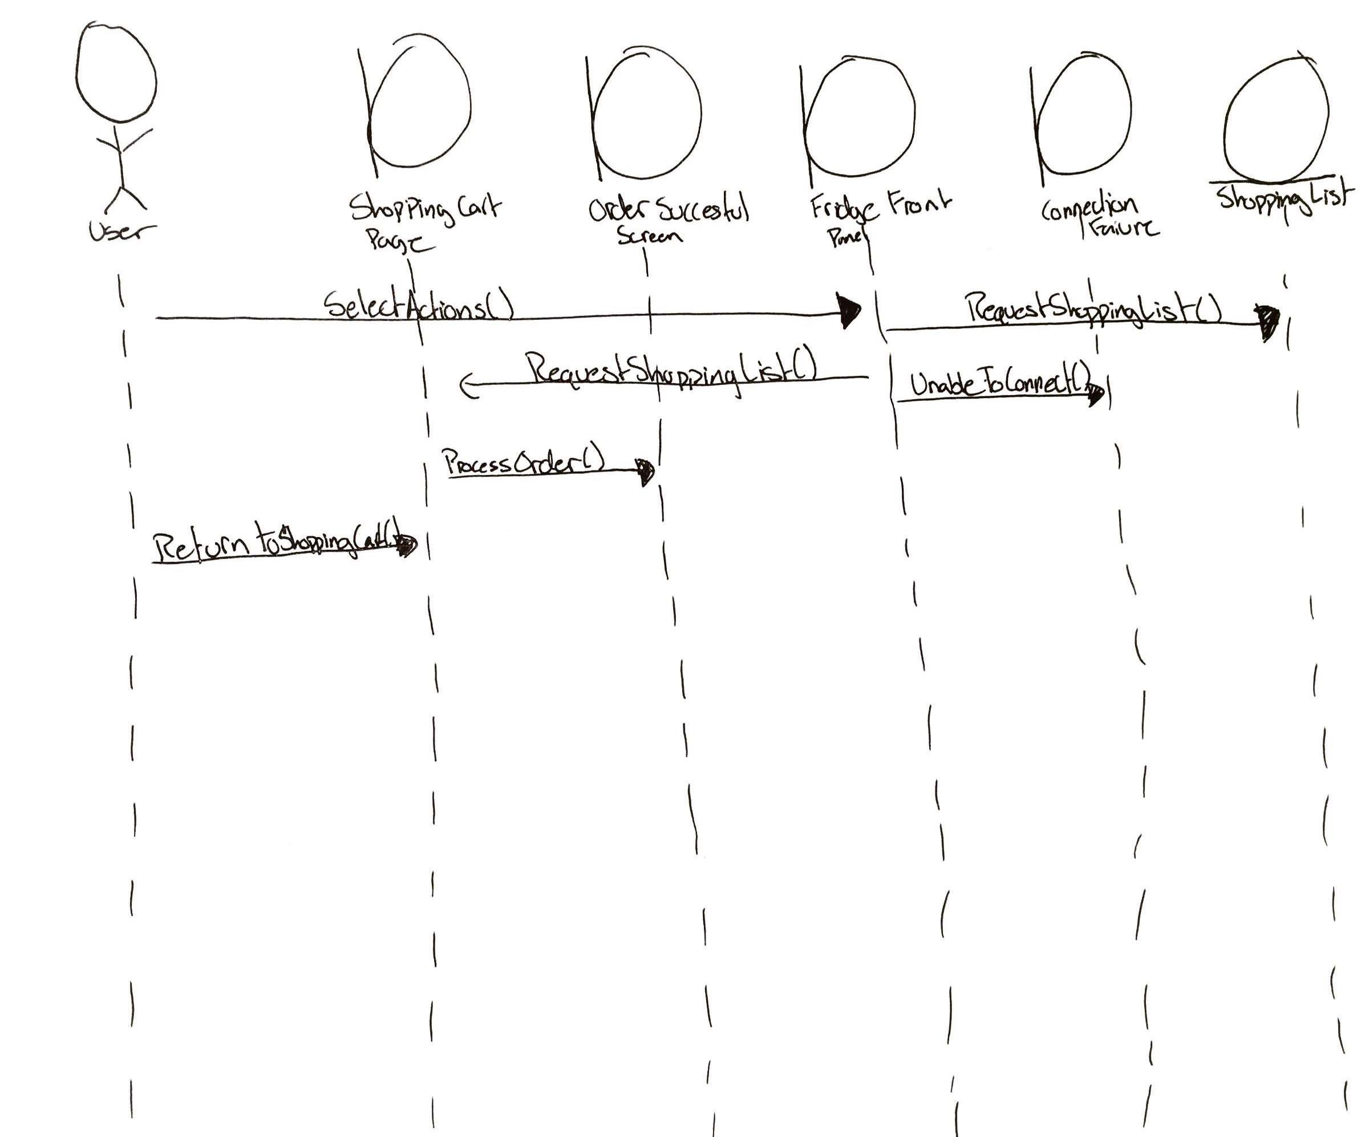

**Data Flow Diagram: Order Groceries through Amazon Fresh**

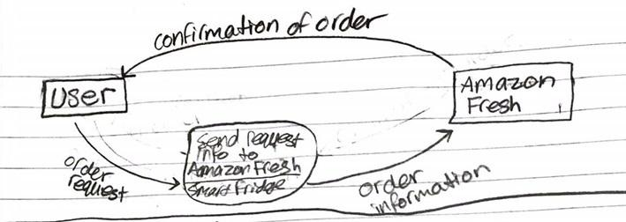

**Glossary**

Frequently used terms and keywords used throughout the documents.

|  |  |
| --- | --- |
| **Term** | **Definition** |
| Refrigerator | Smart Refrigerator with technology to track items within itself |
| Fridge | See: Refrigerator |
| System | Software that runs the refrigerator |
| User | Owner of the smart refrigerator |
| Items | Things that are inside the refrigerator such as food and drinks |
| Ingredients | Items required to make a dish |
| Grocery | Items bought from the store |
| Recipe | Instructions on how to prepare a meal, includes a list of ingredients |
| Recipe database | Database of recipes. Allrecipes.com |
| Expiration | Date of when an item goes bad/spoil |
| Volume | Amount of substance within an item |
| Food delivery service | Service that delivers food to residence |
| Amazon Fresh | Food delivery service |
| Current Inventory | List of items currently in stock and their quantities |
| Master Inventory | List of items that should be in the refrigerator and their quantities |
| Shopping list | List of items need to be add to get current inventory list to master inventory list standards |
| Tracking system | System used to determine items and their quantities in inventory |
| Computer | Includes Windows, Mac, and Linux |
| Smart device | Phones such as Android, iOS, Windows Phone or tablets, and computers. |
| View | Screen or page displayed by the Smart Refrigerator System |
| Main View | The main screen or home page initially displayed by the Smart Refrigerator system |

**Domain Model**

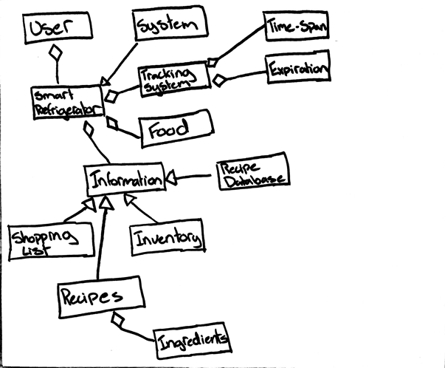

**Class Diagram**

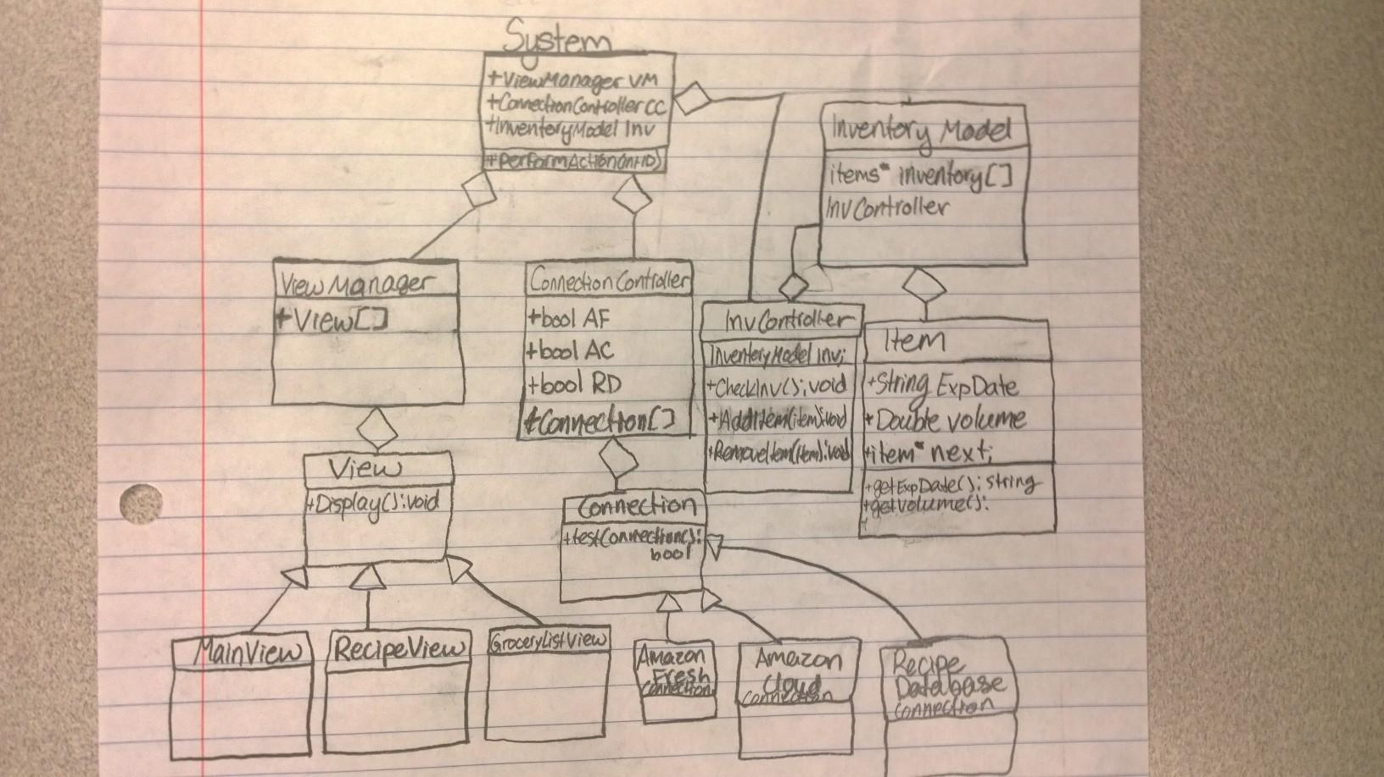

**UI Wireframes**

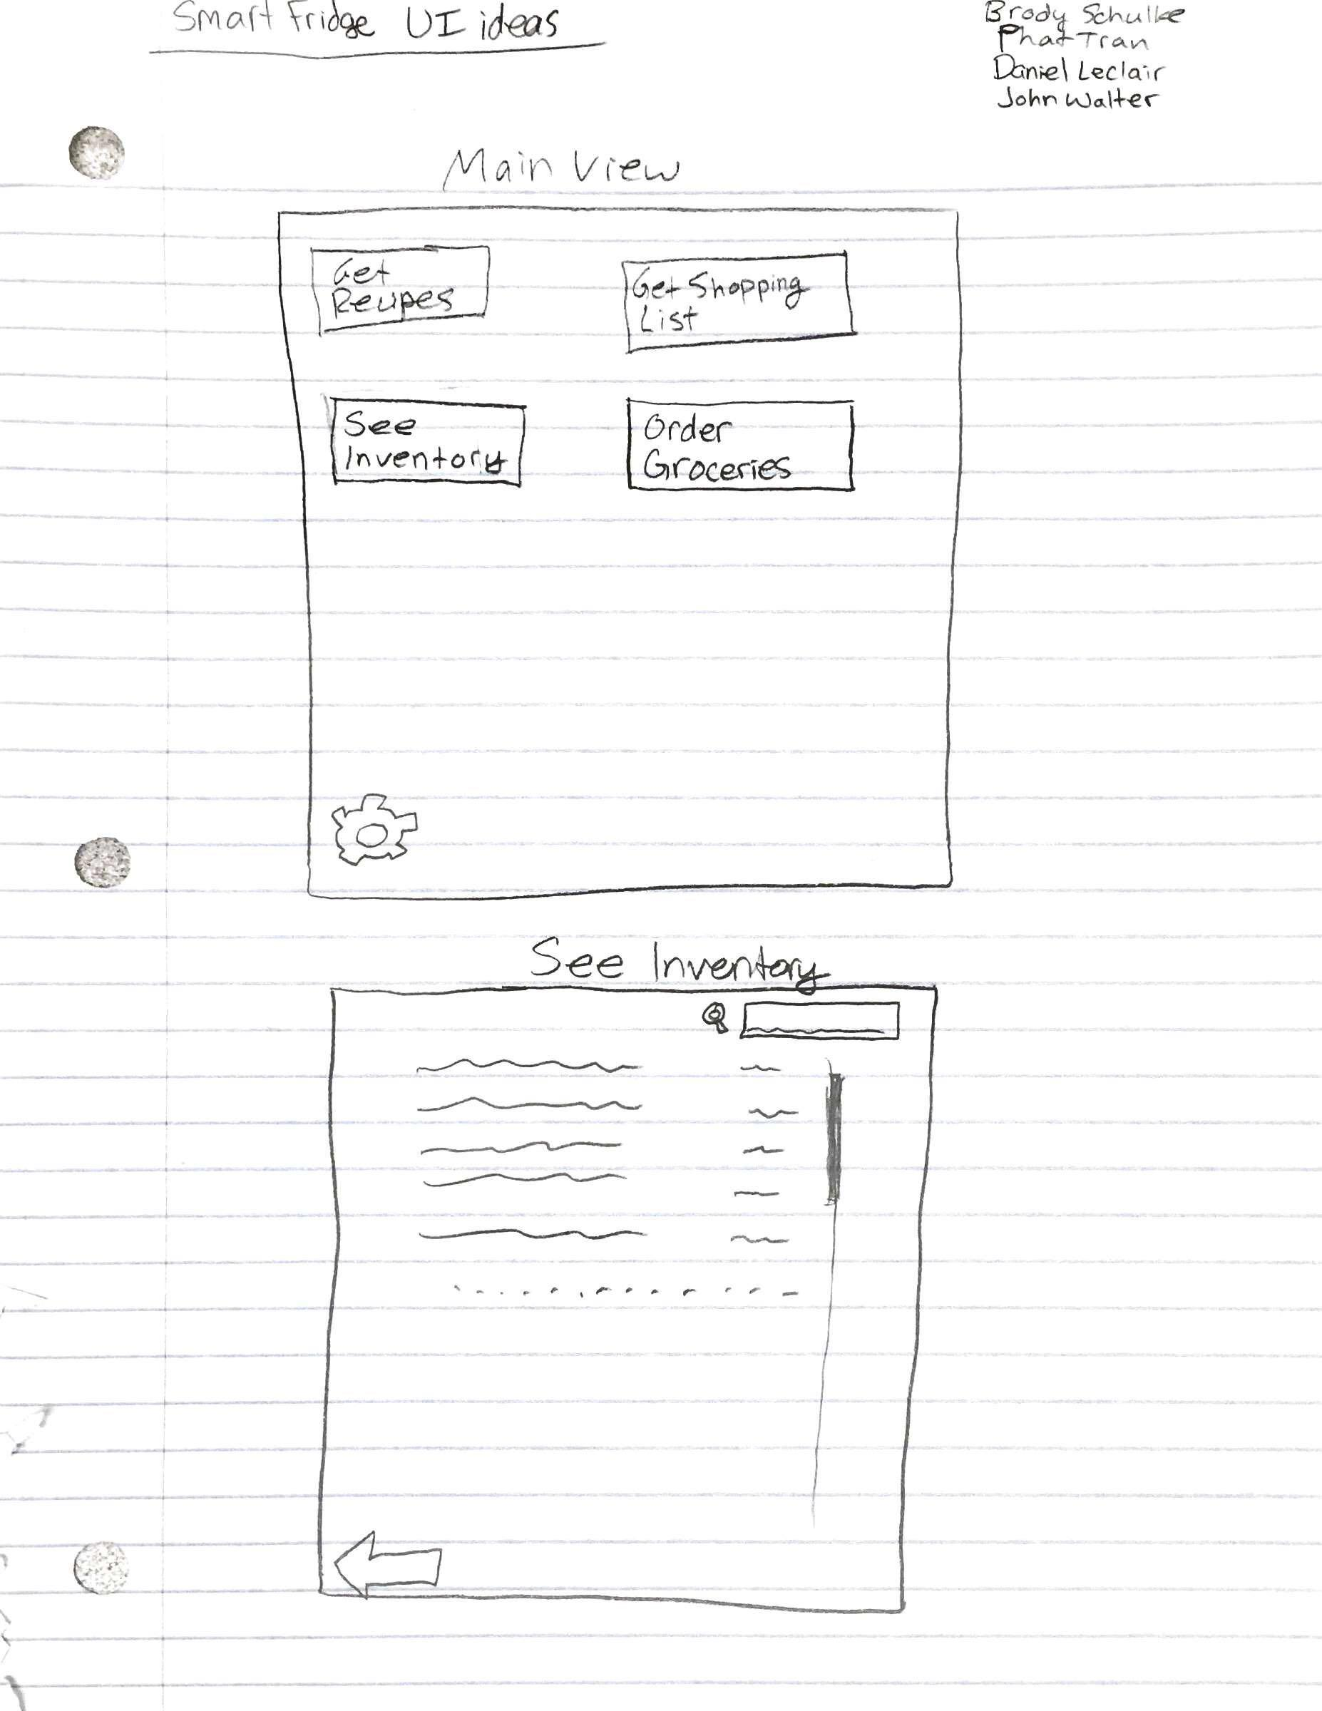

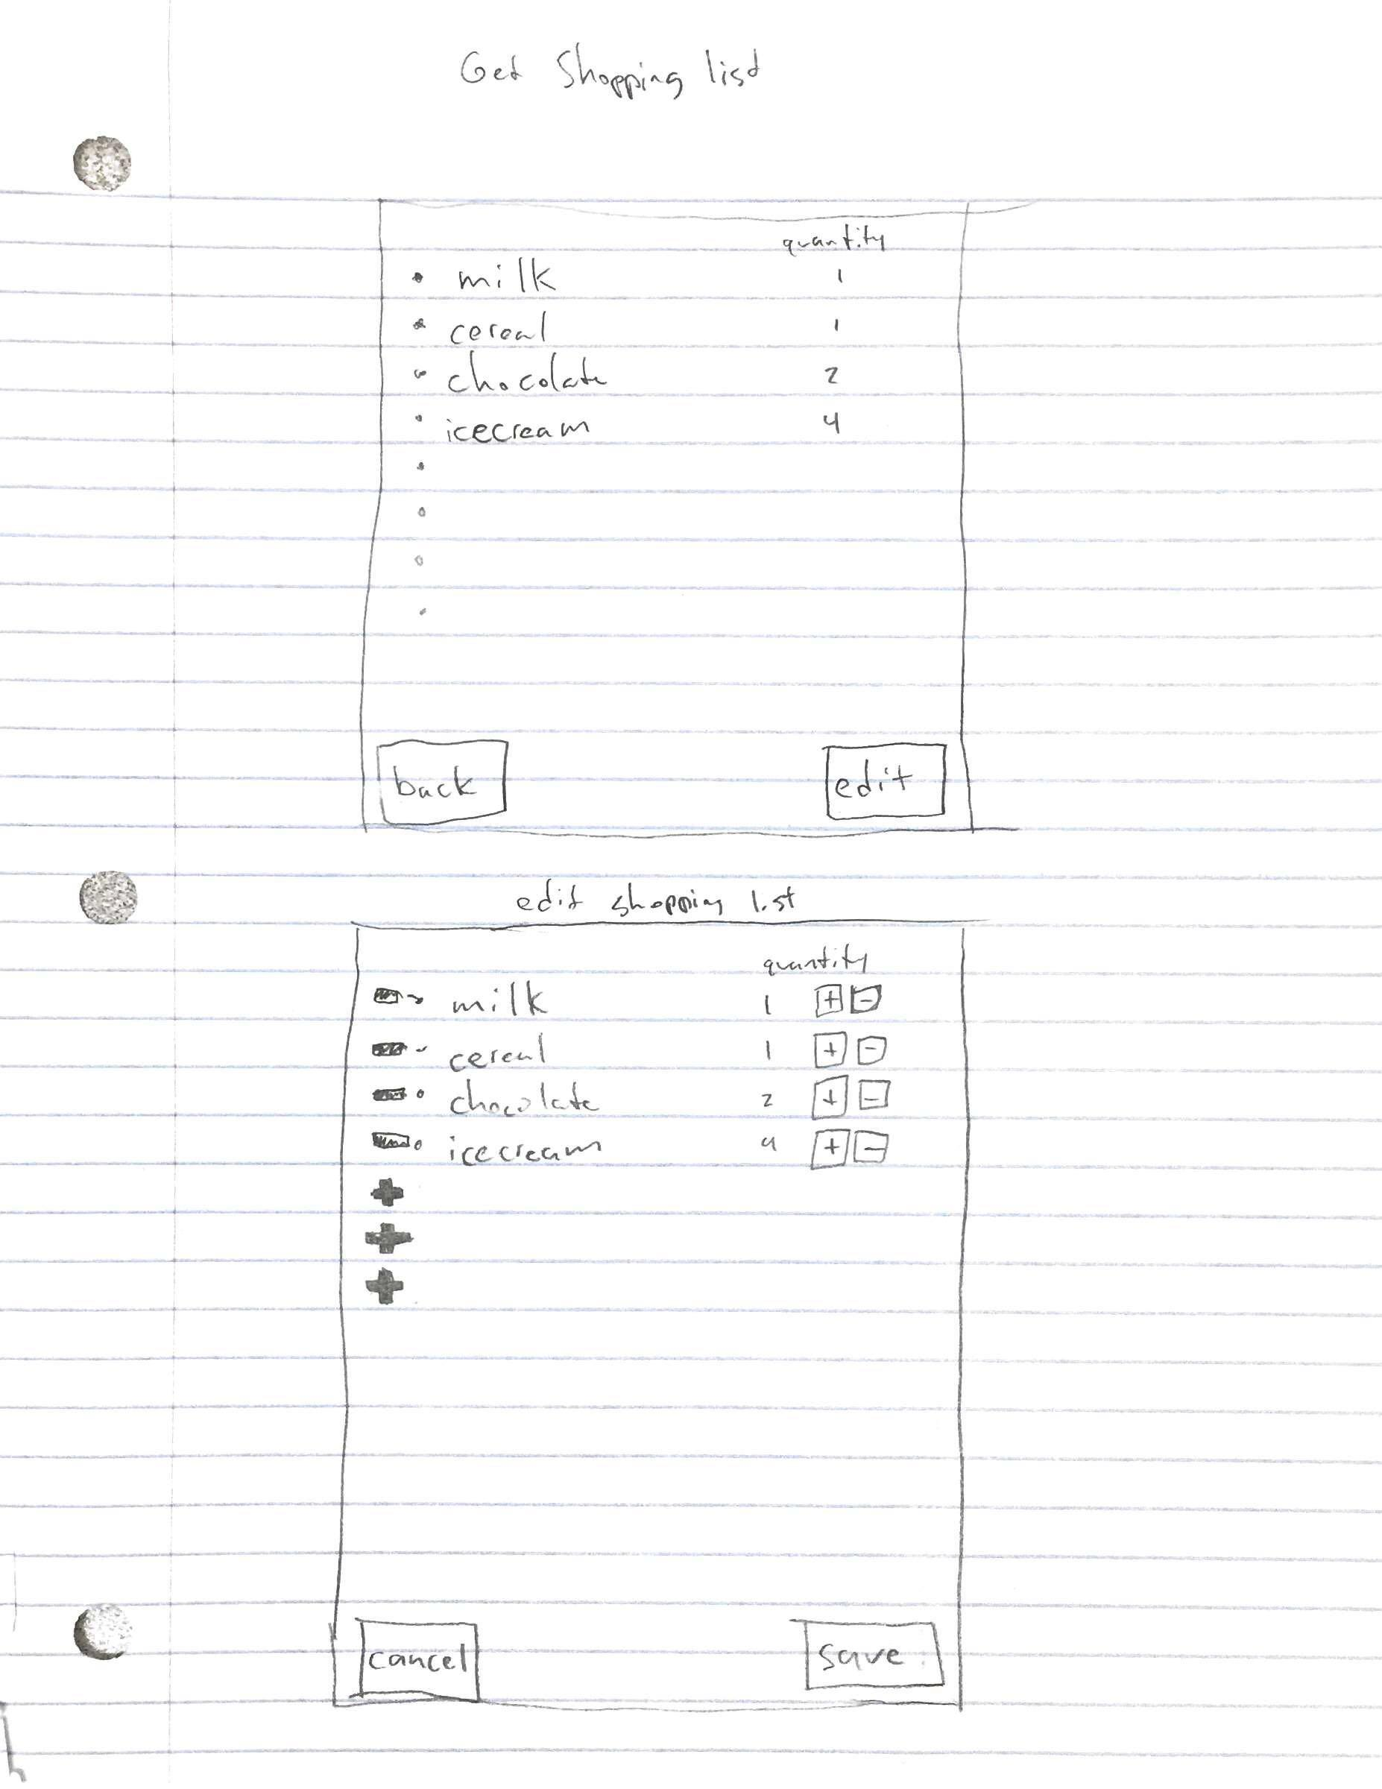

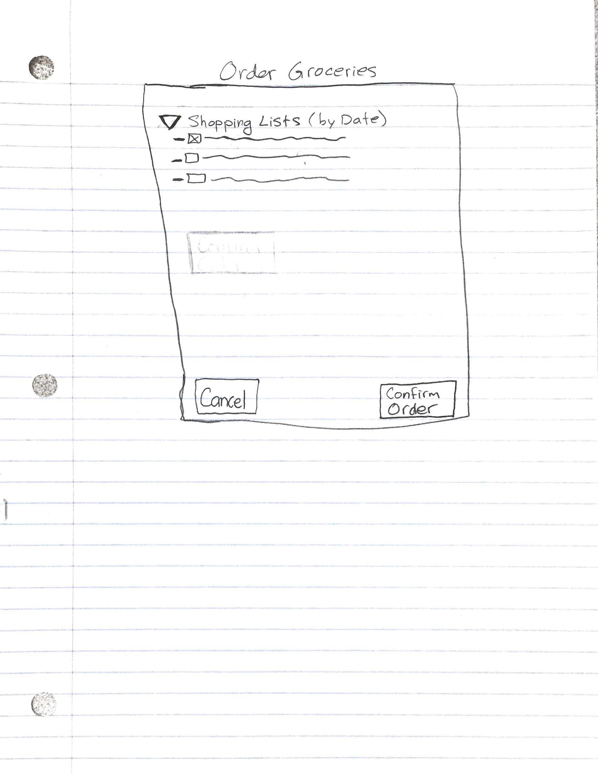

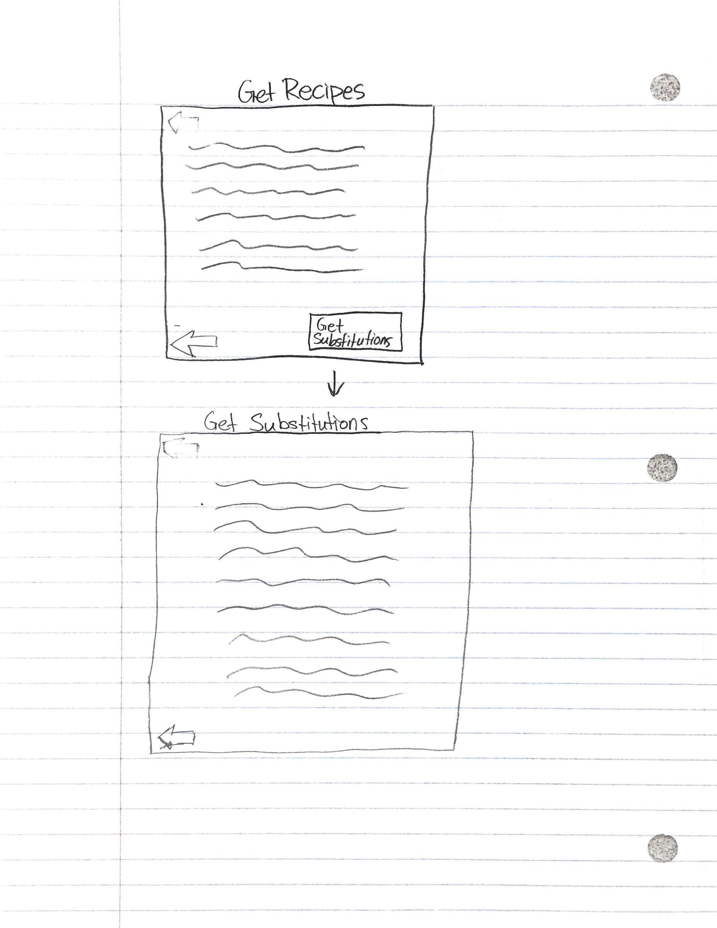

**Architecture Diagram**

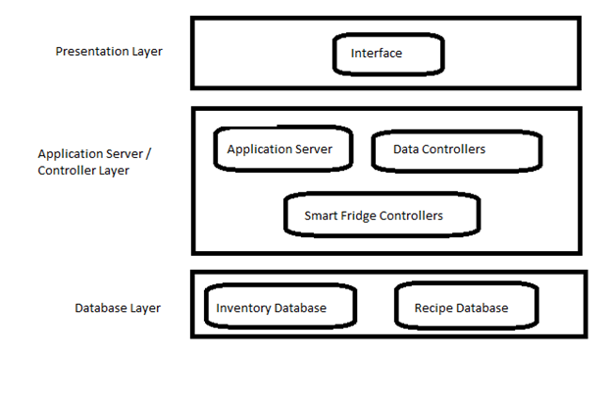

**Deployment Diagram**

